Chainmaille Designer

Welcome to Chainmaille Designer, a program intended to make it easy to design and visualize chainmaille inlay work. By inlay work, of course, we mean graphic designs woven into chainmaille sheet by the use of rings of different colors, whether the different colors are from using different materials, such as copper, aluminum, titanium, and steel or from using similar materials anodized or coated to color them.

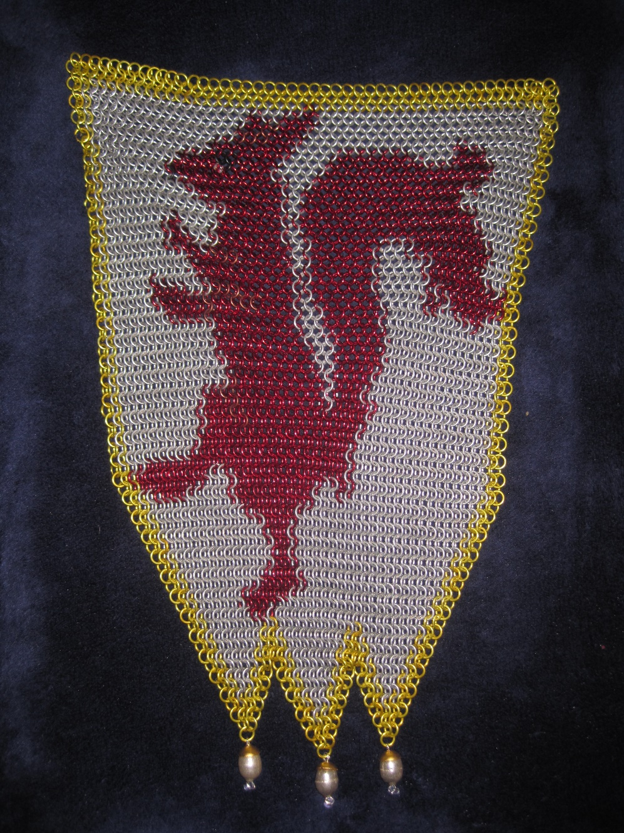  
A simple chainmaille inlay:  
Rampant Squirrel banner in anodized and bright aluminum.

Contents

Program Installation 7

What to Expect 7

Chainmaille Designer Concepts 8

Design Concepts 8

Subject Matter 8

Weave 8

Topology 9

Scale 9

Colors 11

Program Concepts 12

IGP 12

Configuration Directories 12

Files 12

Images 13

Onward! 15

Get Me Started!! 16

First Impressions 16

Configuration 16

Copy Old Files (if any) 17

Start a New Design 17

The (Nearly) Blank Canvas 21

Painting 22

Using the Palette 23

Saving Your Design 24

…And You Are On Your Way 24

Managing Your Designs 25

Using the Main Menu 25

File 25

Design 25

Colors 27

Window 27

Help 27

Directories and File Organization 28

Directories 28

Using the Configuration Window 28

File Organization 29

Creating a Design 30

New Design Window 30

Choose a Weave Window 30

Back to the New Design Window 32

Saving a Design 35

Opening a Previously-Saved Design 35

Chainmaille Designer Design Files 35

IGP Image Files 35

Closing a Design 36

Changing Design Information 36

Design Information Window 36

Using the Design Area 38

Painting Rings 38

Using the Standard Palette 39

Palette Sections 40

Selecting Colors to Paint With 40

Coloring the Rings 40

Un-coloring Rings 40

Painting Rings of a Particular Size 41

Painting Lines and Other Shapes 41

The Shapes Control 41

The Fill Control 41

Painting a Shape 42

Cancelling Shape Painting 43

When Shape Painting is Complete 43

Outline and Background Colors 44

Zoom and Scroll 44

Zoom 44

Scroll 45

Guidelines 45

Guidelines, Zoom, and Rotation 45

Overlays 47

Overlay Images 47

Manipulating the Overlay Image 48

Rotating the Overlay 48

Stretching, Squashing, and Zooming the Overlay 48

Panning the Overlay 49

Using the Overlay as a Guide to Painting Rings 50

The Overlay Control 51

Coloring Rings from the Overlay 51

The Overlay Image in the Design File 54

Counting Colors 55

Color Counts 55

Detailed Color Report 56

Build Information in Pattern Files 57

Replacing Colors in Your Design 58

Replace Colors in Design Window 58

Defining a Color Replacement 60

Effecting the Replacement 61

A More Dramatic Change 61

Defining Palettes 62

Editing a Palette 62

Editing Palette Sections 63

Editing Palette Colors 63

Choose a Color 64

Using the Color Tool 64

Specifying Color Components 65

Sampling a Color from an Image 65

When You Are Done with a Color 67

Weave Patterns 68

Sheets and Rings 68

Edges, Corners and Wrapping 68

Scales 69

Available Weaves 70

Decoding IGP Weave Names 74

Weave 74

Gauge 74

Inner Diameter 74

Putting It All Together 74

Avoiding Such Nonsense 74

Organization of Weave Patterns 75

IGP and Chainmaille Designer 76

Important Differences between IGP and Chainmaille Designer 76

IGP Functionality Implemented in Chainmaille Designer 79

Functionality New to Chainmaille Designer 80

Zoom 80

New Designs and Design Editing 80

Printing 81

Colors, Palette, and Palette Editor 81

Color Counting 82

Inlay Overlays 83

Weave Specification 83

Other Features 83

Acknowledgements 84

Appendix: File Formats 85

A Brief Introduction to XML 85

Pattern File Format 86

Example Pattern File 90

Design File Format 98

Example Design File 100

Palette File Format 101

Example Palette File 102

# Program Installation

To install Chainmaille Designer, simply download and run the ChainmailleDesigner.exe. This is a self-extracting installer, which unpacks the 260-odd files (mostly files that define the various weaves) then runs the setup program which copies these files to the right places on your computer.

## What to Expect

The first thing you’ll see is the Windows prompt asking if you want to allow this app from an unknown publisher (that’s me!) to make changes on your system. After you say Yes to that, you’ll see another little window asking if you want to install Chainmaille Designer; say Yes to that too. You’ll see a progress bar as the installer unpacks itself, and when the unpacking is done you’ll see a “Preparing to Install” window with another progress bar. Before too long, it is replaced with a window that actually shows some chainmaille.

The Welcome window identifies the program and lets you know that you are about to install it. Clicking on the Next button gets you to the license agreement. As of version 3.0, Chainmaille Designer is licensed under the standard GNU General Public License, version 3, which is a standard license for free software.

Once you accept the terms (by clicking on “I accept…”), the Next button gets you to a window where you can change where it is installed on your system. Most people will be happiest by just clicking Next. This gets you to a final confirmation window “Ready to Install…”. For what it’s worth, this is your last chance to cancel the installation.

Clicking the Install button starts copying the files to where they need to go. There is a progress window, but it goes by quickly and is replaced by the “Completed” window. A check box in the middle of this window allows you to start running the Chainmaille Designer immediately; if you don’t want that, uncheck the box before clicking on the Finish button.

Assuming you decided to run the program, you’ll see the two windows of Chainmaille Designer itself: a narrow palette window and a larger design window. If you’re anxious to get started, especially if you have previously worked with the Irregular Grid Painter (IGP), you’re welcome to skip right to “Get Me Started!!”, possibly after a side trip to “IGP and Chainmaille Designer”. If, on the other hand, you prefer a more leisurely introduction or just appreciate a more organized presentation that starts from first principles and works its way up to the full range of capabilities of the software, read on.

# Chainmaille Designer Concepts

## Design Concepts

An inlay design has several conceptual components.

### Subject Matter

The subject matter is the actual graphic image or theme that is intended to be depicted in the final work. This part, of course, is entirely up to you (although it’s best to avoid copyright violations). You can start with a photograph, painting, sketch, or even just a general idea of the kind of thing you want to depict. I once opened up a design with no more of an idea than “water; I want it to give the impression of water”.

If you have a specific image in mind, though, Chainmaille Designer lets you bring in that image as an overlay to your design which can be moved around, scaled, stretched, and squashed to fit the extent of your design, then used as a guide to assigning colors to the rings.

### Weave

The construction pattern used to connect the rings into a sheet is called the weave, although in this program (and in its predecessor, IGP) the weave is also called the pattern. When you start a design in Chainmaille Designer you’ll have the opportunity to select a pattern file which establishes the weave for your design.

If you’re just starting out and don’t know what weave to choose, I recommend beginning with the European four-in-one weave; it’s straightforward and easy. On the other hand, if one of the other weaves available from within the program captures your imagination, run with it! When you build your design, you’ll be investing many hours into the process, so it makes sense to choose a weave that you like the look of.

|  |  |  |  |  |
| --- | --- | --- | --- | --- |
|  |  |  |  |  |
| European 4-in-1 | Japanese 4 in 1 | Japanese 6-in-2 | Dragonscale | Scales |

A few weaves (and some scales) from the collection.

When you’re ready, I encourage you to go beyond the program by exploring sites like the Maille Artisans International League. There are many hundreds of ways of weaving rings into sheets, at least a dozen of which lend themselves very nicely to inlay work. If you find one you really like, you can write the pattern file for it and make it available to the rest of us!

### Topology

The topology of a design (indicated in the program as the *wrap*) specifies the way in which the edges of the design connect, if they connect. A design that is equivalent to a flat sheet (a banner or tabletop cover, for example) does not wrap; in the program it has a wrap of “none”. Similarly, a design that represents a band, such as a collar or bracelet, which will be closed by a clasp has a wrap of “none” because even where the band will be joined by the clasp, the weave itself has a definite edge. On the other hand, a design that represents a continuous band, such as a collar, headband, necklace, ring, or bracelet that connects to itself *via the weave* can be said to wrap either horizontally or vertically. If you prefer to design the band so that it crosses the design space from left to right, or vice versa, specify the “horizontal” wrap. If, instead, you prefer the band to cross the design space from top to bottom, specify the “vertical” wrap.

In some cases, the choice of horizontal vs. vertical wrap goes beyond preference into requirement because of the orientation of the weave in the designer. For example, one of my favorite weaves to make bracelets with is Dragonscale (fourth from the left in the weave examples above), with all of the small rings in rubber and the large rings in metal. Because of the structure of the weave itself, if I have the band cross from left to right (with horizontal wrap) the resulting bracelet has almost no stretch along its length, but if I specify the band as taller than it is wide (with vertical wrap) the resulting bracelet has plenty of stretch to be pulled over the hand yet nestle snugly against the wrist.

### Scale

The scale of the design includes its width and height and the actual sizes of the rings you will be using.

#### Pattern Units, Rows & Columns, and Distance Measures

The physical extent (width and height for a vertical piece, or width and depth for a horizontal one, or width and length for something like a bracelet) can be set when a design is first being defined. The most natural measure for the physical extent (at least from the viewpoint of building the chainmaille) is in units of the weave itself.

From a visual viewpoint, however, it can make more sense to want to define the extent in terms of the visual rows and columns; this allows you to more directly determine the resolution of the image you would like to present so that the important details (the hairiness of the squirrel, or the readability of letters) will be sufficiently distinguishable.

On the other hand, you may need to fill a space that’s more easily defined in ordinary measures of distance, whether it’s a cover for a small tabletop that’s 30 by 40 centimeters or a custom bracelet that needs to be 7-3/4 inches long.

Chainmaille Designer lets you do all of these, and even to switch between them. As they say though, “some restrictions apply”: to move between chainmaille units and actual distances, you must have already decided on what weave you want and what size(s) of rings you will be using.

If you never err in estimating the size of your work, more power to you! On the other hand, if, like me, you occasionally discover, partway through execution, that you need to alter the physical extent of your design, Chainmaille Designer makes it easy to add to (or subtract from) any of the edges of your design without invalidating the rest of the design.

#### Ring Sizes

##### Inner Diameter and Wire Gauge

Ring sizes are typically given in terms of their inner diameter (because you’ll be fitting other rings inside that diameter) and the thickness of wire from which the rings are made. The program adopts the convention of specifying the inner diameters in inches and the thickness of the wire in the American Wire Gauge (AWG). 18G 3/16, for example, specifies a ring with an inside diameter of 3 16ths of an inch made of 18 gauge wire.

A pattern file can specify any number of ring sizes (or combinations of ring sizes for weaves that use more than one ring size), and once you have chosen the weave, you will often be able to choose the ring size(s) you wish to work with. Don’t worry if the size you want isn’t part of the pattern file, though; just keep in mind that conversion to distance units (per above) may not be accurate in that case.

As a tangential note, there are two principal wire gauge systems, the AWG (also known as the B&S gauge) and the Standard Wire Gauge (SWG), which obviously wasn’t as standard as it wanted to be. Because these gauges are really measures of the area of the wire’s cross section, *not* its diameter, neither one can be converted to distance using a simple conversion factor. For example, to convert inches to AWG involves taking the logarithm base 92. I have embedded the correct conversion formulae deep inside the code, but most people use conversion tables.

##### Aspect Ratio

Rings for weaves are often specified by aspect ratio, or AR. This is simply the ratio obtained by dividing the inside diameter of the ring (in distance units) by the thickness of the wire (also in the same distance units). For example, a weave can specify that it must be constructed using rings with an AR of at least 3.2. Pay attention to these specifications. Especially well-characterized weaves can specify minimum, maximum, and ideal ARs. In general it will not be possible to build a weave using rings below the minimum AR because there is not enough room inside the rings for the other rings to fit 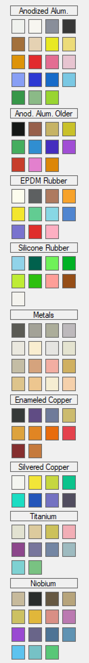into. Weaves built with ARs close to the minimum will tend to be tight and inflexible. Weaves built at the ideal AR will be “just right”. Weaves built with ARs close to the maximum will tend to be loose and floppy, while weaves built with ARs above the maximum may completely lose pattern coherence or, in the case of captive ring weaves, simply fall apart.

### Colors

The rings you will be using to depict the subject matter of your design will typically be restricted in terms of the colors available. Naturally, as you design, you’ll want to use colors that are reasonably close to those of your actual materials to get a better idea of what your design will look like once it has been executed.

#### Palettes

A palette is a relatively small collection of colors that represents the colors you have to work with (as contrasted with the 16 million or so distinguishable colors, or many more for some people). Chainmaille Designer allows you to choose a palette for each of your designs. There are many organizing principles possible for a collection of colors, but my most important is: can I obtain rings in that color, and if so, from where? My favorite supplier of rings is a Canadian company, The Ring Lord, so as an example of what can be done, with the idea that it may very well be sufficient for most people, I’ve included a palette of the colors available from The Ring Lord.

#### Palette Sections

Now, The Ring Lord sells hundreds of different sizes and shapes of rings in 19 materials (at last count), each with its own range of colors. There’s a whole spectrum of colors in anodized aluminum, a different spectrum in niobium, another in EPDM (a latex-free rubber), more in enameled copper, titanium, etc., and then there are the basic metals: stainless steel, blackened steel, copper, brass, bright aluminum, etc. I didn’t want to put them all into one great heap and call it a palette, so I built in the ability to define palette sections. For the Ring Lord palette, I created a palette section for each material so that if I wanted to make a piece from anodized aluminum it was clear exactly which colors I could work with.

You don’t have to buy your rings from The Ring Lord, or even use my palette, if you don’t want to, though. Chainmaille Designer makes it easy for you to build palettes of your own, even sampling photographs of the rings to get accurate colors.

## Program Concepts

You don’t need to know all of these concepts to work the program, but you will need them to understand how the program works.

### IGP

You’ve seen IGP this and IGP that throughout this exposition, and you’ll see more later. What is IGP anyway? IGP stands for Irregular Grid Painter, a program written in Visual Basic by Zlosk around 2003 which anyone who was designing inlays used (unless they were using hex grid paper). For the first time ever, IGP allowed computer users to color in rings in the context of their arrangement within a weave to define a design. One of the principal design criteria for the Chainmaille Designer was that it at least be able to do what IGP did, preferably without invalidating anyone’s previous designs or pattern definitions.

### Configuration Directories

Configuration directories are just directories of files (or, in Windows parlance, folders) that are where the program expects to find certain kinds of files. Chainmaille Designer expects to be told where to find pattern files, where to find and put palette files, and where to find and put your designs.

One of the first things you’ll want to do if you have designs that you used with IGP is either copy or move your old files into the design directory configured for Chainmaille Designer, or to use Chainmaille Designer’s Configuration window to point to the directory in which your designs already reside. [Note: it is not necessary to copy the weave pattern files.]

### Files

#### Pattern Files

A pattern file, as explained earlier, defines a weave in a way that the program understands. Chainmaille Designer understands the pattern files used by IGP (in the old .ini file format) as well as the more capable XML pattern files distributed with Chainmaille Designer.

Both kinds of pattern file just have a top-level description of the pattern. To implement the pattern, they refer, in turn, to other files, mostly image files. To successfully move a pattern file requires moving the entire collection of related files as a unit.

#### Palette Files

A palette file represents a palette of colors. A palette can be divided into sections, and each section can define one or more optionally-named colors, either as red-green-blue (RGB) triples or as hue-saturation-luminance (HSL) triples. So, for example, a palette file may define a color named “seafoam” in the “Anodized Alum.” section as having the HSL values of 167, 110, 190.

#### Design Files

A design file represents a design. This includes at least the weave used, the physical extent of the design, and a reference to an image file that specifies the colors assigned to each ring. If you have specified them in the process of defining your design, the design file may also include information about the color palette used, the size of rings used, the overlay image (if any) and its positioning with respect to the design, and information about who created the design, for whom it was created, when it was created, and additional descriptive matter.

A design file also carries some information about how you set up your workspace. Some examples of this kind of information are any guidelines you may have placed in your design area and palette sections that you chose to hide while working on the design. Using this information, opening a saved design can set up the Designer pretty much the way it was when the design was saved.

#### Color Report Files

Like IGP before it, Chainmaille Designer can save or print a file that summarizes how many rings of each color are needed by the design as well as a row-by-row specification of the order of ring colors in that row. These amount to step by step instructions on how to construct the final work, provided one already has a grasp of the weave itself.

### Images

#### Color Image

A color image is an image in which each single pixel represents the color of one ring. Using a color image allows the design coloration to be represented in a much smaller file than would be needed for a picture of the design with all of the ring shapes.

  
Color image for Dragonscale bracelet of fire.

#### Rendered Image

A rendered image is a picture of the design, with the outlines of each ring where they ought to be, and each ring colored appropriately. Normally, the rendered image is built by the program using the design information from the design file and maintained invisibly behind the scenes, but the rendered image can be printed or saved to an image file (for reference while building or for presentation to a client, for example).

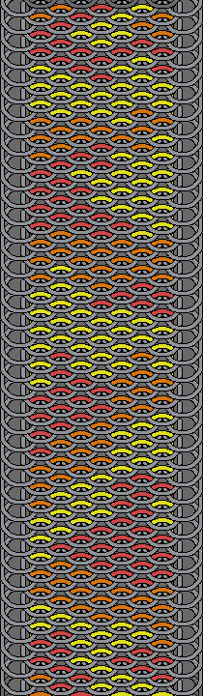  
Rendered image for Dragonscale bracelet of fire.

#### Zoomed Image

The zoomed image is the image that appears in the design area of the main window. To build the zoomed image that you view, the program takes just that portion of the rendered image that ought to be visible and scales it up or down to fit the design area. Because the scaling of the already-rendered image is much faster than painting each ring, this allows the program to respond with more alacrity as you zoom in and out and pan around the design.

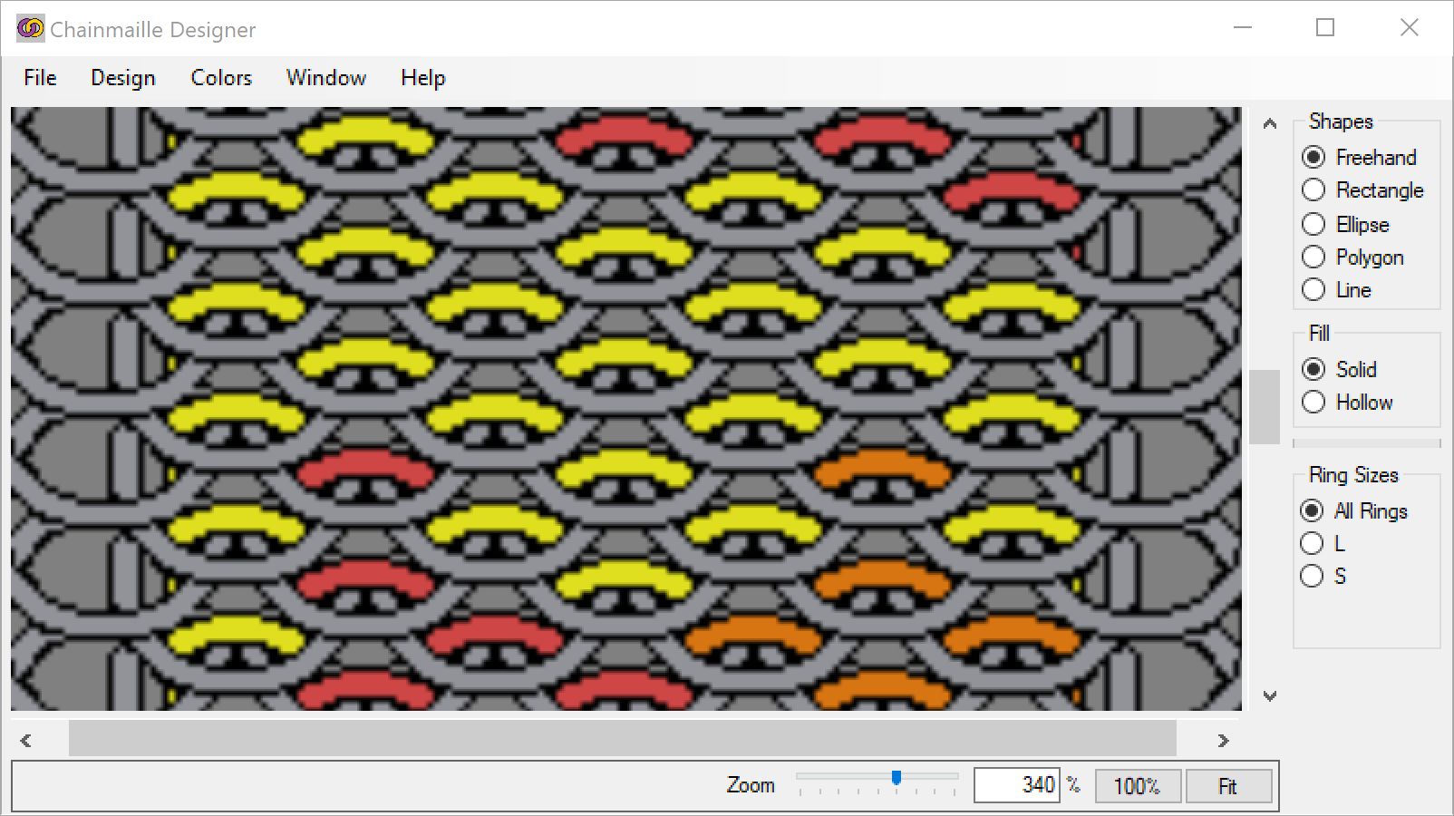  
Zoomed image for Dragonscale bracelet of fire in Chainmaille Designer (340%).

Zooming into a design, especially a very large design, can make it a lot easier to color exactly the rings you want to color, particularly on today’s high-resolution monitors.

## Onward!

By now you have a pretty good background for being able to use and understand the program, so let’s get you started with using the program, then we’ll resume our more detailed discussion after that.

# Get Me Started!!

## First Impressions

When you bring up the program, you will see two windows. The narrow window is for your palette of ring colors. The wider window is your main window, dominated by the design area in the center, with menus on the top and a few indicators and controls on the bottom and the right side.

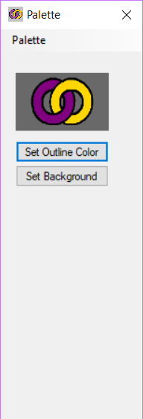 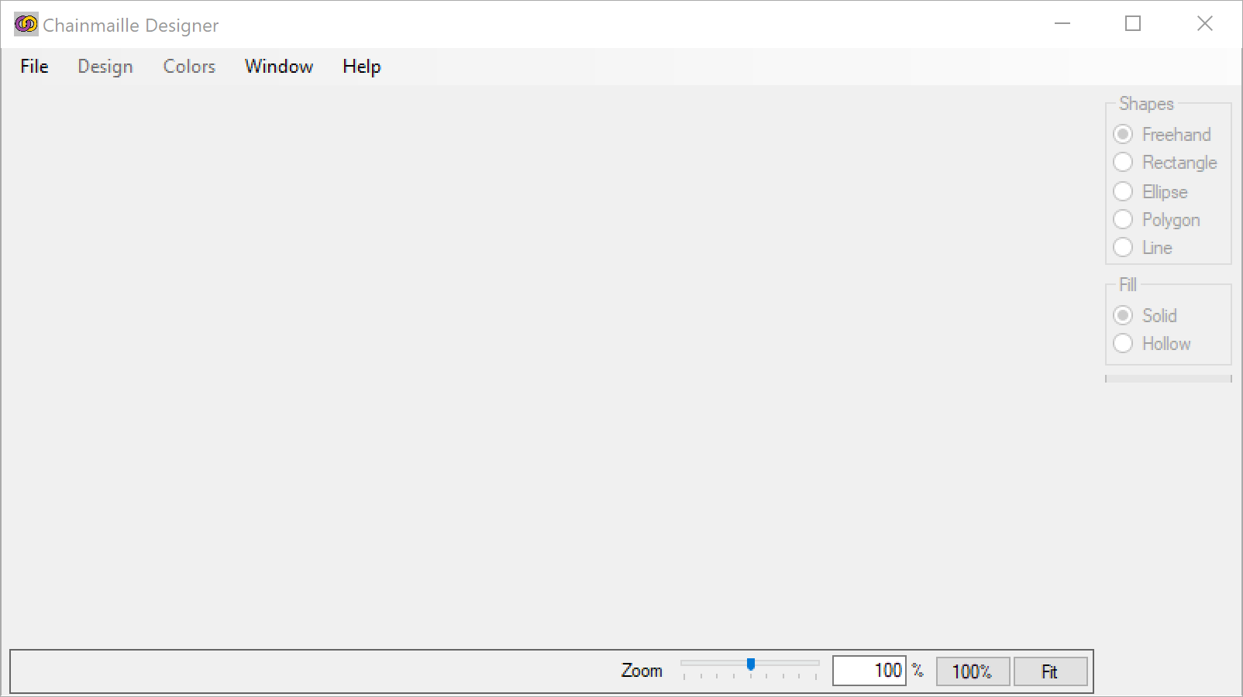  
The palette window and main window of Chainmaille Designer.

We won’t need the palette just yet, but it is always on top when shown. This is how it should be when you’re doing what you’ll mostly be doing, painting rings, but it can get in the way when you’re first setting up a design, so hide the palette by clicking on the X in the upper right corner of the palette window. (We’ll get it back later when we’re ready to paint rings.)

## Configuration

Before we try anything else we should set up the configuration which tells the program where to find the various kinds of files. To begin, select Help > Configuration from the menu. The Configuration window appears.

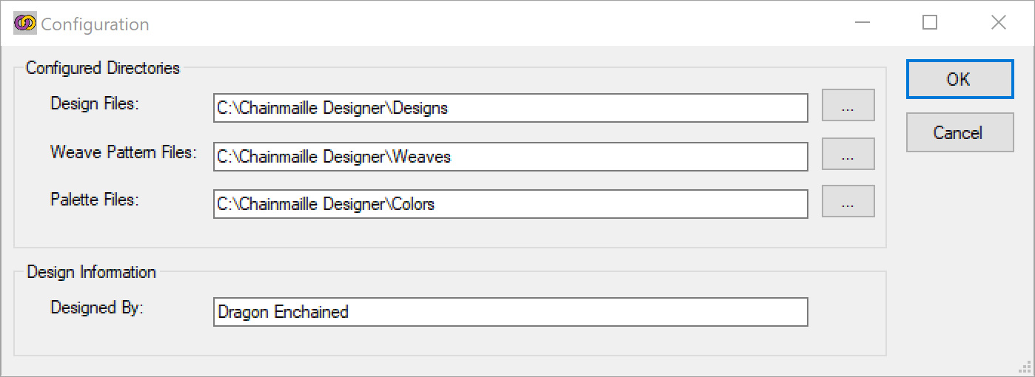  
Configuration window.

There are three configurable directories, one for your designs, one for the pattern files that define the weaves, and one for the palette files that define the colors you can work with. If the configuration as installed works for you, jolly good! If not, you can change any of the directories by clicking on the browse button (the one with the ellipsis, …) next to the directory you wish to change. This brings up a standard directory-choosing window from which you can navigate to the directory you wish to use.

While you’re in the configuration window, enter your name or the name of your business or organization in the Designed By field. Finally, click on the OK button to return to the main window.

## Copy Old Files (if any)

If you have design image files from IGP, now is the time to copy or move them into the design directory you’ve configured for Chainmaille Designer. I have already converted all of the old IGP weave patterns that I could find to work with Chainmaille Designer, so you shouldn’t have to move those, but if you have any special ones you can copy them into the weave pattern files directory as they are.

## Start a New Design

To begin the design process, take a moment to think of what you might want to do, then select File > New from the menu. The New Design window appears. This window has two tabs, the Weave and Size tab for the essential properties of the design and the Information tab for other information about the design.

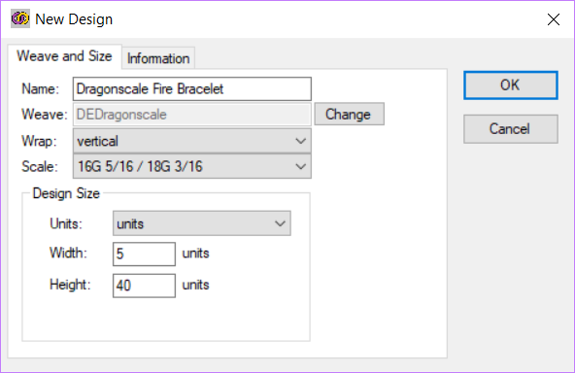

At the top of the first tab, enter a name for the design.

Next, choose a weave for the design. Ordinarily, this defaults to the weave you used most recently, but this is your first time in so go ahead and click on the Change button next to the space where the weave name would be. This brings up the Choose a Weave window. You can select a weave from the list by either double-clicking on it or single-clicking to select it, then clicking the OK button.

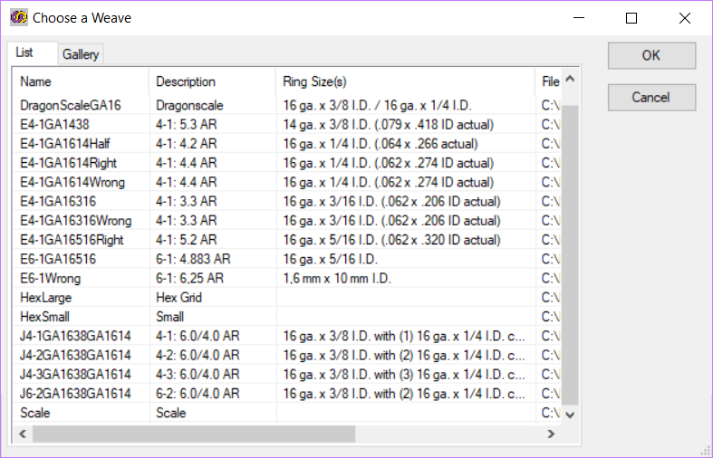

Alternatively, you can switch to the Gallery view and choose from amongst the weave images in the same way.

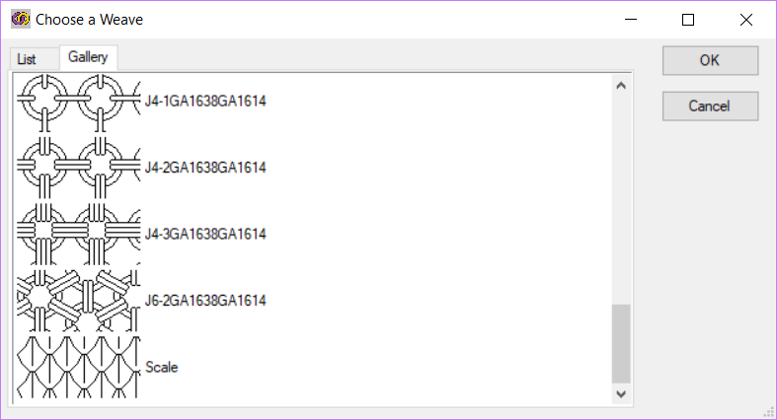

Once you select a weave, you’ll be back in the New Design window where you can set the wrap and, if more than one scale was defined for the weave you chose, the scale for the design. (If there’s only one scale in the weave pattern file, it will be preselected for you.)



Specify the size of your design by entering a width and height. By default, this is in the natural units of the selected weave. If you wish, you may first set the units in which the design is specified. If you do select units other than the units of the chainmaille weave, you’ll be faced with yet another choice: whether the specified size should be treated as a minimum or maximum given that the design will have an integral number of chainmaille units in each direction.

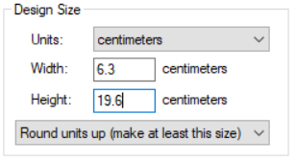

Click on the information tab to enter whatever additional information you want to be carried with the design. The Date defaults to now (in UTC) and the Designed By field defaults to whatever you entered in the Configuration window (you did enter that, right?).

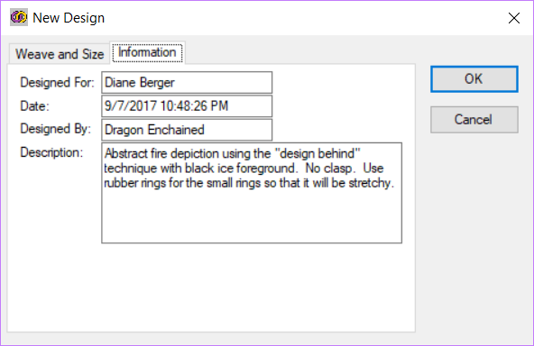

When all of the initial design information is entered to your satisfaction, click on the OK button. A new, uncolored design will be created from the information you entered and it will be displayed in the central design area of the main window.

## The (Nearly) Blank Canvas

With the preliminaries out of the way, you’ll be able to see the beginnings of your first design on the main window. Before you jump into painting, take a few moments to notice what’s already there.

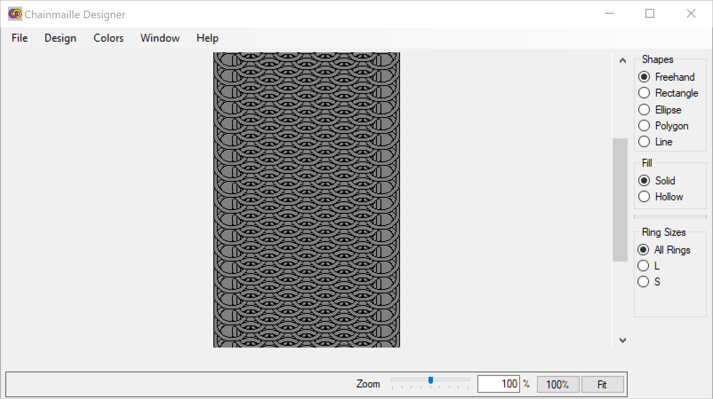  
A new uncolored design.

First, there’s something in the design area! Yay! It is even the size you told it to be. In the case above, the initial zoom is 100% but the design is rather tall compared to its width so you can’t see the whole thing (the scroll bar on the right is also a clue).

There are four zoom controls along the bottom of the window. Go ahead and play with them to get a feel for how they work. There is the slider (the middle position is 100%), the entry field that lets you type in a zoom factor, the 100% button which instantly returns the zoom to 100%, and the Fit button which adjusts the zoom so that the entire design is visible. If you position the mouse cursor over the design area, you can also use the mouse wheel to zoom in and out.

Along the right edge are the painting controls. We’ll get to them a bit later.

## Painting

It is now time to color some rings, but the colors are in palettes and we told the palette window to hide itself, so the first thing to do is to bring the palette window back by selecting Window > Show Palette from the menu. The palette window reappears, but it looks nearly empty.

To fill the window with the vivid colors you crave, you’ll need to open a palette file. Using the Palette menu on the palette window itself, select Palette > Open. This brings up a standard file open window, and if the configuration is correct it will start in the directory where the standard palette file (Ring Lord Colors) is stored. To begin using the standard palette, double click on the Ring Lord Colors file (or select it, then click on the Open button).

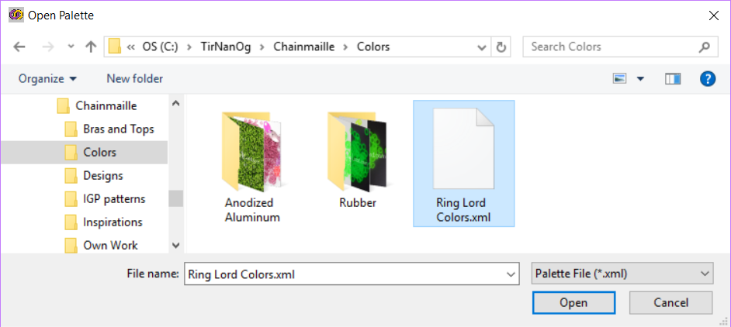

## Using the Palette

That’s more like it. Now we see lots of colors. How can we use them? Nothing could be easier. I should start by saying that you can paint on the design area by using the left or right button of the mouse (assigning a different color to each, if you wish), either single-clicking to paint one ring at a time or using click-and-drag for a more continuous application of color.

To assign a color to a mouse button, just click using the appropriate button on a color patch in the palette. You’ll notice that the image at the top of the palette window changes when you do this; this is your reminder of which color you have assigned to each button: the ring on the left shows the color assigned to the left button, the ring on the right shows the color assigned to the right button.

You *un*-paint by holding down the Alt key on your keyboard, then using either button of the mouse to click (or click and drag) in the design area. If your mouse has a functional middle button you can also use that to un-paint. Un-painting assigns the *transparent color* to the ring you clicked on. Transparent rings are not considered part of your finished design and are not counted by the color counter (more on that later).

Of course, you can’t paint ring colors on the background or outlines, only on the rings. How do you know you’ve got the mouse pointed to a ring? Either you zoom in enough that you can’t possibly miss your intended ring (a good idea anyway) or you can watch the indicator in the lower left of the main window. When you are over a ring, this area will show the unit column number, unit row number, and the number of the ring within its unit (depending on the weave, a single chainmaille unit can be composed of anywhere from 1 to 14 rings; the last number tells you which ring of the unit you are pointed at). The numbers are followed by the color name from the palette, if any.

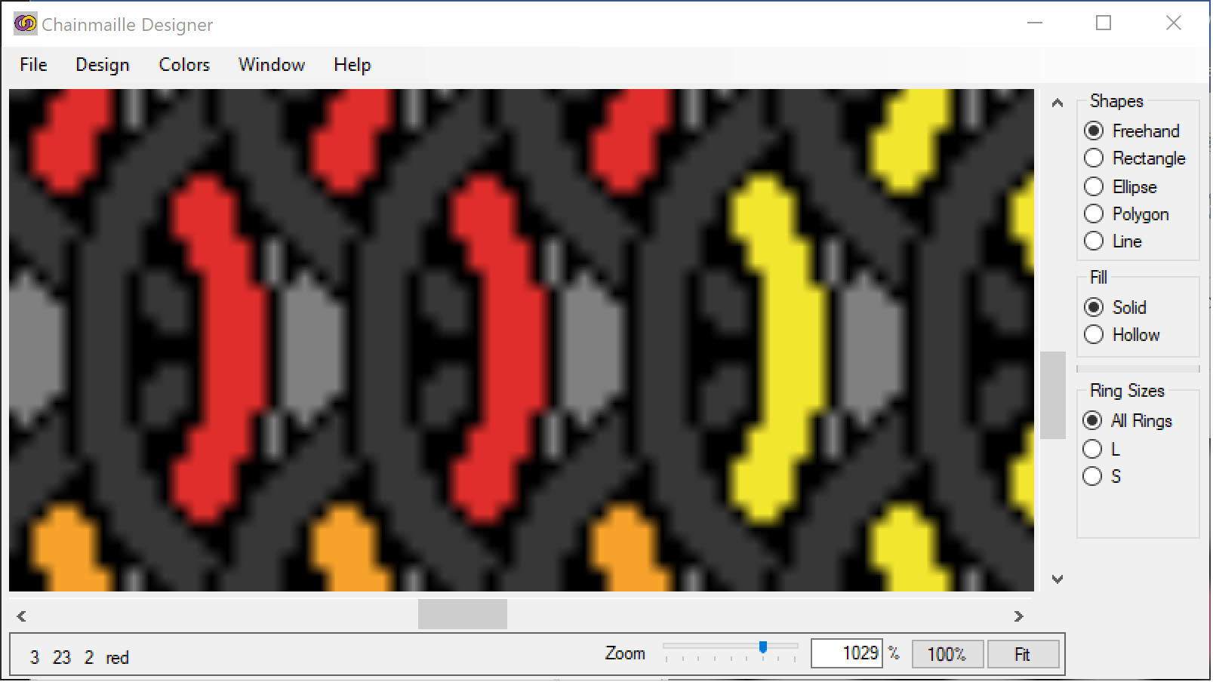  
You probably don’t have to zoom in this much to color the ring you want (but you can).  
As shown in the lower left corner, the central ring is in column 3 of row 23 and is the 2nd ring of its chainmaille unit. Its palette color is red.

## Saving Your Design

When you’ve painted a bit, it’s time to save what you have done so far. From the menu of the main window, Select File > Save Design As. This brings up a standard save-as window with the file name conveniently defaulted to your design name. Click the Save button to complete the action.

## …And You Are On Your Way

That’s all you really *need* to know to use the program to design your inlay projects, so go ahead and play some more if you wish, but I am naturally anxious to share the full extent of my cleverness with you, so when you are feeling indulgent (or even mildly curious) I encourage you to read further.

# Managing Your Designs

## Using the Main Menu

The main menu provides the operations with which you create and manage your designs.



### File

The File menu allows you to begin a new design, save a design, or open a previously-saved design. It also allows you to save or print an image of your design.

**New** – Begins the process of defining a new design using the New Design window (see ***Design Information, New Design Window***, below).

**Open** – Allows you to choose a previously-saved design from the Open Design window. In addition to opening Chainmaille Designer design files, the image files created by IGP (well, really, **any** image files) can be opened as a design. [Image files don’t have weave information (or anything other than colors), so after you open them you’ll need to go to Design > Info to set the weave and other design parameters.]

**Close** – Closes the current design, removing it from the designer (but not before prompting to save if any changes were made).

**Save Design** – Saves the design in its design file. If no design file has yet been associated with the design, prompts you for a design file name and location.

**Save Design As** – Saves the design in a (possibly) new design file, prompting you for a design file name and location.

**Save Rendered Image** – Saves an image of the design, similar to that shown in the design area of the main window, to an image file of your choosing.

**Print > Rendered Image** – Prints an image of the design, similar to that shown in the design area, to a printer of your choosing.

**Exit** – Exits the Chainmaille Designer program.

### Design

The Design menu allows you to review or change the parameters of your design. It also allows you set guidelines and to bring in an overlay image to act as a guide to coloring the rings.

**Info** – Shows design parameters in the Design Information window, from which the design parameters can also be changed (see ***Design Information, Design Information Window***, below).

**Guidelines > Hide** – If guidelines are defined for the design and are being shown, hides them.

**Guidelines > Show** – If guidelines are defined for the design but are hidden, shows them.

**Guidelines > Horizontal** – Adds a horizontal guideline to the design at the next position you click within the design area.

**Guidelines > Vertical** – Adds a vertical guideline to the design at the next position you click within the design area.

**Guidelines > Halves** – Adds guidelines to the design which divide the design into halves both vertically and horizontally.

**Guidelines > Thirds** – Adds guidelines to the design which divide the design into thirds both vertically and horizontally.

**Guidelines > Quarters** – Adds guidelines to the design which divide the design into quarters both vertically and horizontally.

**Guidelines > Clear All** – Clears all of the guidelines from the design.

**Overlay > Open** – Begins the process of setting up an overlay image. An overlay image is shown semi-transparently over your design as an aid to assigning ring colors (see ***Overlays***, below).

**Overlay > Hide** – If an overlay is defined for the design and is being shown, hides it. On the keyboard, alt-o hides or shows the overlay.

**Overlay > Show** – If an overlay is defined for the design but is hidden, shows it. On the keyboard, alt-o hides or shows the overlay.

**Overlay > Rotate > Clockwise** – If an overlay is defined for the design, rotates it a quarter-turn clockwise while leaving the underlying design as it is.

**Overlay > Rotate > Counterclockwise** – If an overlay is defined for the design, rotates it a quarter-turn counterclockwise while leaving the underlying design as it is.

**Rotate > Clockwise** – Rotates the entire design (including its overlay, if any) a quarter-turn clockwise.

**Rotate > Counterclockwise** – Rotates the entire design (including its overlay, if any) a quarter-turn counterclockwise.

### Colors

The Colors menu provides access to the color counter and the ability to replace colors already in your design with other colors.

**Count Colors** – Displays a report showing how many rings of each color will be required to execute the design (see ***Counting Colors***, below). From this summary report, a more detailed report can also be obtained.

**Replace in Design** – Displays a window which allows you to replace selected colors of your design with other colors, either from the current palette or arbitrarily chosen (see ***Replacing Colors in Your Design***, below).

**Color Rings from Overlay** – Assigns colors to the rings based on the colors of the overlay image, but restricted to the colors in a chosen palette section (see ***Coloring Rings from the Overlay***, below).

**Clear All Ring Colors** – Returns all of the rings in the design to the uncolored state.

### Window

The Window menu controls the visibility of Chainmaille Designer windows. At present, only the palette window can be controlled in this way.

**Hide Palette** – If the palette window is being shown, hides it.

**Show Palette** – If the palette window is currently hidden, shows it.

### Help

The Help menu provides access to the “About box” and to program configuration as well as the expected advice about how to use the program.

**About Chainmaille Designer** – Displays an informational window identifying the program, its creator, and its reason for existence.

**Configuration** – Shows program configuration parameters (directories and user information) and allows these to be changed (see ***Directories and File Organization***, below).

**Show Help** – Displays the contents of this manual in web help file form with a table of contents, an alphabetical list of topics, and the ability to search for a term of interest.

**License Agreement** – Displays the license agreement that you agreed to when installing the program.

## Directories and File Organization

### Directories

Chainmaille Designer expects the files it works with to be found within one of three particular directories (also known as folders):

**Design Files** directory – This is where Chainmaille Designer expects to find (and put) your designs.

**Weave Pattern Files** directory – This directory contains all of the chainmaille weave pattern definition files available for use with the Chainmaille Designer.

**Palette Files** directory – This directory contains palette definition files, which define the colors for your designs.

These directories are created in a default location (nominally C:\Chainmaille Designer) at installation time. If you wish to change, for example, the place where your designs are stored, you can do so through the Configuration Window.

### Using the Configuration Window

To view or change the configuration, begin by selecting Help > Configuration from the main menu. The Configuration window will appear.



The current definitions for the three directories are displayed in the upper area of the window. To change one of them, click on the button with the ellipsis (…) to the right of the directory. This brings up a standard directory-choosing window from which you can set the directory you wish to use.

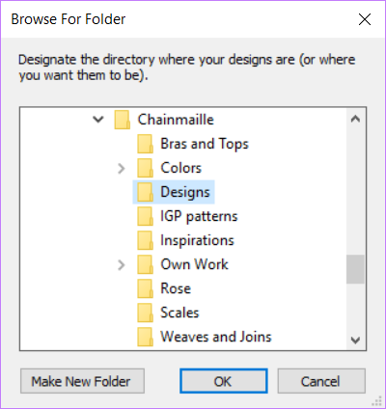

The Configuration window also provides a place for you to enter your name, or the name of your company or organization, as the originator of your designs. This information, if present, will be included in each of the designs you create with the Chainmaille Designer.

### File Organization

Within the design and palette files directories, you are free to organize your files however you see fit.

The weave pattern files directory is a little more restricted: in general, each weave must have its own directory which contains all of the files necessary to work with that weave. This includes (at least) a weave definition file (either XML or .ini) and one or more image files. Above that level, up to the weave pattern files directory itself, you can organize the weaves however you like, but there is rarely any reason to do so: when needed, the program hunts through all of the files and folders under the weave pattern files directory for weave definitions and presents them all in the Choose a Weave window, irrespective of the organization of their directories.

## Creating a Design

To begin creating a new design, select File > New from the main menu. This displays the New Design window.

### New Design Window

The New Design window has two tabs. The Weave and Size tab is where all of the essential information is entered. The Information tab is for entering more descriptive information.



#### Name

At the top of the Weave and Size tab, enter a name for the design. This name is the basis for the names of the design file and its related files, so it shouldn’t be left blank, be too general, or be too long.

#### Weave

Next, choose a weave for the design. Ordinarily, this defaults to the weave you used most recently. To change the weave from the default (or set the weave if no default is displayed), click on the Change button next to the box where the weave name is shown. This displays the Choose a Weave window.

### Choose a Weave Window

The Choose a Weave Window presents all of the weaves in the configured weave pattern files directory (Help > Configuration to change the directory). You can select a weave for your design from the list of available weaves by either double-clicking on it or single-clicking to select it, then clicking the OK button.



Alternatively, you can switch to the Gallery view and choose from amongst the weave images in the same way.



### Back to the New Design Window



#### Wrap

Once the weave is chosen, the next choice is the topology of the design, known more simply as the wrap. For most projects, the default wrap of none is appropriate. If, however, your design is to be woven in the form of a cylinder (a continuous bracelet, for example) then you’ll want to specify the wrap as horizontal (if the left edge is woven into the right edge) or vertical (if the top is woven into the bottom).

|  |  |  |
| --- | --- | --- |
|  |  |  |
| No Wrap has all edges & corners | Horizontal Wrap has only top & bottom edges | Vertical Wrap has only left & right edges |

Sometimes this choice depends on the orientation in which the weave is presented in the Designer. As an example, Dragonscale is very stiff in one direction (the horizontal direction as the Designer shows it by default) but quite mobile (expandable and compressible) in the other direction (vertical in the Designer). To make stretchy Dragonscale bracelets (using rubber for the small rings and metal for the large ones), I have to set it up so that the stretch that is needed is along the mobile direction, so I specify a vertical wrap and orient the bracelet so that its length is from top to bottom of the design area. (Then, once I am back in the design area, I rotate the design so that the length of the bracelet lies horizontally across my screen.)

If you are using one of the old IGP weaves that do not have edges or corners, the wrap is still useful information about the design, but you will not see a difference in how your design appears in the Designer. At present, only weaves with “DE” in their name (for “Dragon Enchained”) specify edges and corners, but I expect this to change.

#### Scale

The next choice is the choice of scale: What ring sizes will you be using to execute the design. This choice is based on the ring sizes defined in the weave pattern files, and to date there are not any which define more than one scale. This means that the scale box will either be empty and have no choices (if the weave didn’t define a scale) or will have some rings sizes but not allow a choice of alternate ring sizes (if the weave defined only one scale). Not really much of a choice at present, but I’ll show you later how to add scale information for your favorite ring sizes to your favorite weaves, after which this selection will be more useful.

If the weave also defines the number of weave units that fit within an inch horizontally and vertically, then there is enough information to convert weave units to distance units (inches or centimeters). When this is the case, it allows the design size (in the next section of the window) to be specified in inches or centimeters. Regrettably, only one weave, DEDragonscale, had this information at the time of release.

#### Design Size

The last area of the Weave and Size tab is the Design Size section. This has a units selector and areas to enter the width and height of the design in the selected units. The possible units are:

**units** – Weave units as defined by the weave pattern file. These are repeating elements that collectively define the weave.

**rows & columns** – Visual rows and columns (see discussion of Scale in ***Design Concepts***, above).

**pixels** – Number of pixels in the color image (see ***Program Concepts***, above). Not recommended. This was the only way to specify design size in the IGP, so it is here for those who are used to it, but it depends on the way in which the weave file defines the arrangement of colors for the weave units, which is non-obvious.

**inches** – Distance measured in inches. This option is not presented if the weave file doesn’t have enough information to relate weave units to distance units.

**centimeters** – Distance measured in centimeters. This option is not presented if the weave file doesn’t have enough information to relate weave units to distance units.

Specify the size of your design by entering a width and height. If you select units other than the units of the chainmaille weave, you’ll be presented with another choice: whether the specified size should be treated as a minimum or maximum given that the design will have an integral number of chainmaille units in each direction.



For example, if you are making a close-fitting bracelet or collar to measure, you would most likely want to round up because rounding down might make the piece unwearable. On the other hand, if the project is a cover for the floor of a box, rounding down would be a better choice.

#### Descriptive Information

The second tab of the New Design window is the Information tab which allows other information about the design to be recorded: who created the design, when, and for whom, as well as any other notes you like.



The Designed By field is pre-populated with the information entered in the Configuration window (see ***Directories and File Organization***, above). The Date field is pre-populated with the current date and time, UTC.

When you click the OK button of the New Design window, an uncolored chainmaille design will be created from your specifications and displayed in the design area of the main window.

## Saving a Design

To save a design, select File > Save from the main menu. If the design has not previously been saved, you will be prompted for the name of the design file, conveniently defaulted to the name you entered for your design in the New Design window. If you were prompted, click the Save button to complete the action.

To save a design under a different name, select File > Save As from the main menu and enter the new file name when prompted. Click the Save button to complete the action.

## Opening a Previously-Saved Design

To begin viewing or editing a previously-saved design, select File > Open from the main menu. This shows a standard file-choosing window from which you may choose the design file that you wish to work with.

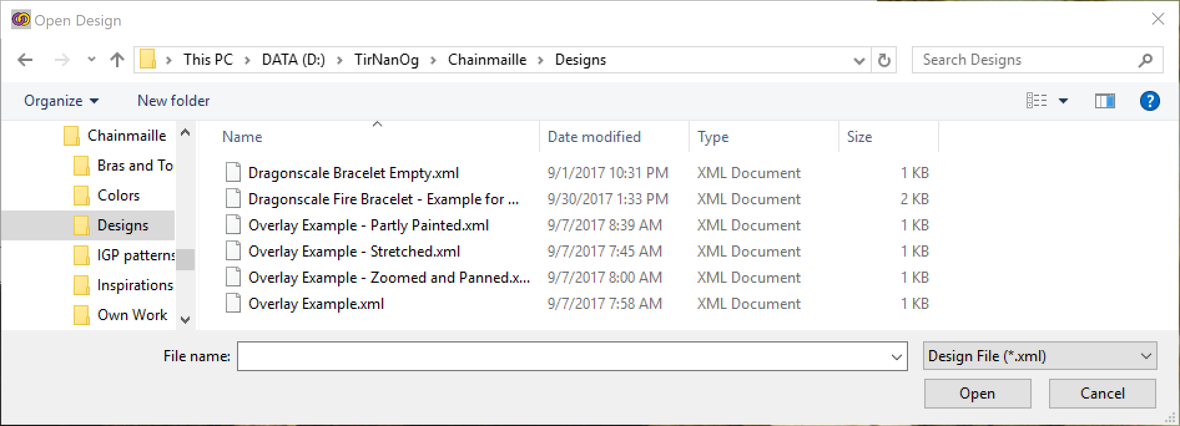

### Chainmaille Designer Design Files

The design files of Chainmaille Designer are in XML format. When choosing a design file to open, the default is to show only XML files.

### IGP Image Files

To open a design created by the old IGP, change the file filter (the drop-down choice in the lower left of the file-choosing window, just above the Open button) from Design File to Image File, then choose your IGP image file.

IGP image files don’t include design information, so after you open the image file, you will need to tell Chainmaille Designer what weave you want to use (see ***Changing Design Information***, below).

## Closing a Design

To stop editing a design, but leave the Chainmaille Designer running, select File > Close from the main menu. You will be prompted to save your design if it has any unsaved changes.

## Changing Design Information

You can review and even adjust the qualities of your design at any time while you are working on it. To review information about your design, select Design > Info from the menu of the main window. This displays the Design Information window.

### Design Information Window

In this window, you can review the information you entered when creating the design and change or add information by typing into any of the text entry areas for Name, Designed For, Date, Designed By, and Description.

You can also change the wrap and scale of your design by using the drop-down lists, just as for the New Design window.

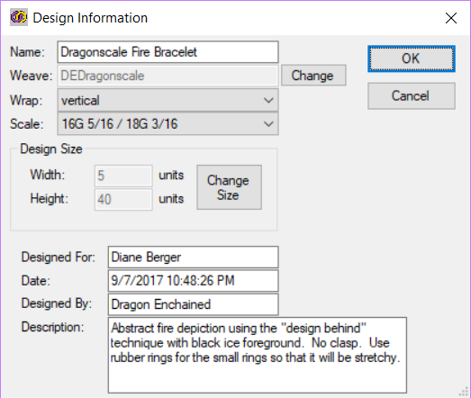  
The Design Information window.

In addition to those rather mundane functions, you can also do two rather special things from the Design Information window: change the weave you are using and change the size of your design.

#### Changing the Weave of a Design

To change the weave of your design, click on the Change button to the right of the name of the weave. This brings up the Choose a Weave window, previously described, from which you can select a different weave. Once a different weave has been selected, you may also have different Scale choices to choose from. From this point, clicking on the OK button of the Design Information window will cause the new weave selection to be applied to your design.

As an example of when this might be handy, when I will be using European 4-in-1 I often prefer to sketch in the design using the SmallHex pattern. It’s a little easier to paint on the contiguous hex tiles and is close enough for the roughing in. With the initial design painted, I then switch to the real weave, say DE-Euro4in1, to check the ring directions at all the color transitions, adjusting ring colors on the boundaries as required.

Changing the weave of an existing design can have unexpected results. Despite the similarity in name, for example, Japanese 4-in-1 is not at all like European 4-in-1 from a structural point of view, so switching an established design from one weave to the other may result in breaking up lines or color boundaries, or otherwise distorting the graphic image. If you don’t like the result of a change of weave, the best recovery is to re-open the Design Information window and change it back, without saving in between.

Because of the potential distortion, instead of reading in a previous design and changing its weave, consider saving the rendered image of the previous design (File > Save Rendered Image), then using the rendered image of the previous design as an overlay for the new design (see the chapter on ***Overlays***, below, for how to do this).

#### Changing the Size of a Design

Chainmaille Designer also lets you adjust the size of your design by adding units to (or removing units from) any of the edges of your design. This is useful when you discover, for example, that the thickness of the bracelet you are making means that you’ll need 2 more rows of units to go around the intended wrist and you want to design the additional rows to blend in seamlessly with the rest of the design.

To begin changing the design size, click on the Change Size button in the Design Size area of the Design Information window. This causes the Change Design Size window to appear.

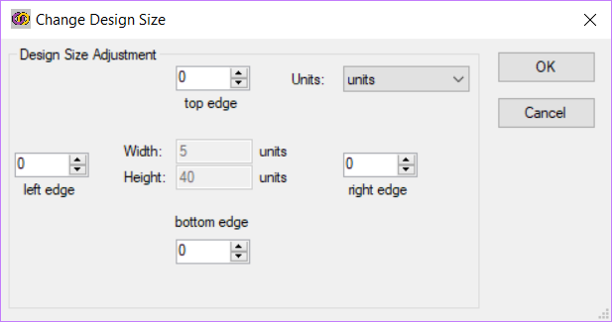  
Change Design Size window.

This window presents the total size of your design (in the center) and provides areas at top, left, right, and bottom to specify a number of additional units for each of the four edges. (To accommodate size reductions, the number of additional units can be negative.) Also note that the upper right corner of the Design Size Adjustment area has a units selector; by default adjustments are in weave pattern units but, as with the original size specification, you can also specify the adjustment amounts in visual rows and columns, inches or centimeters (if you’ve selected a scale for your design), or (for inveterate IGP users) pixels of the color image.

As you enter adjustments for any of the four sides, the overall size (in the center) will also change. For our hypothetical bracelet that needs two more rows, we could just leave the units selector alone, enter 2 into the top edge box, and click OK.

Exiting the Change Design Size window returns you to the Design Information window. Any design size changes you specified are not actually applied to your design until you also click on the OK button of the Design Information window.

Clicking on the OK button of the Design Information window finalizes your changes (if any) and implements them in your design. Any changes to the appearance of your design will be shown in the design area of the main window.

# Using the Design Area

## Painting Rings

When painting rings, you’ll be selecting colors to paint with from the palette, then clicking or dragging in the design area to paint in those colors, then going back to the palette to pick different colors, then doing more painting, etc. so it makes sense to set up the palette window and the main window side-by-side.

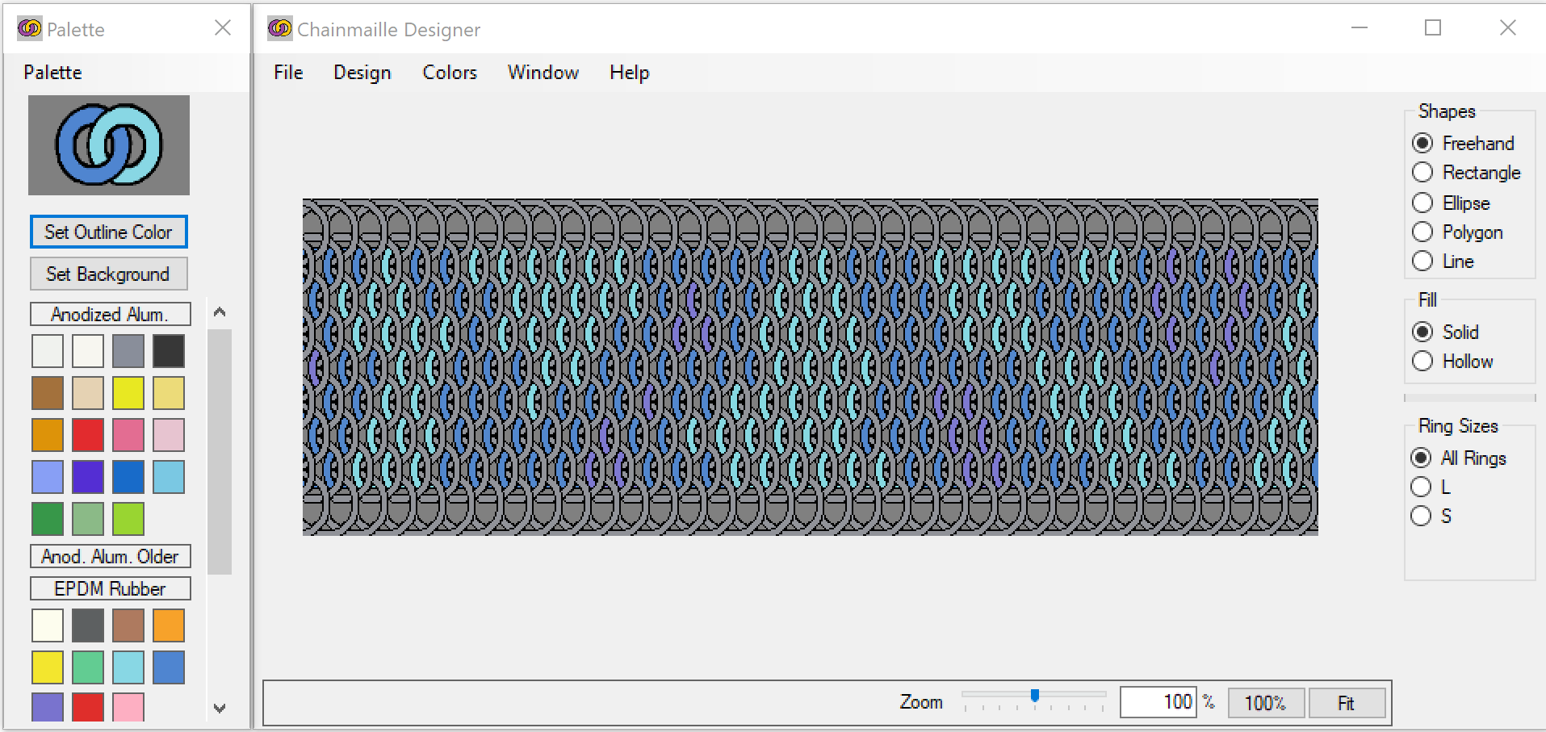

### Using the Standard Palette

The palette window displays the current palette. To show or hide the palette window, select Window > Show Palette or Window > Hide Palette from the menu of the main design window. The palette window can also be hidden by clicking the X in the upper right corner of the palette window itself.

To use the standard palette, select Palette > Open from the menu at the top of the palette window, then locate and select the Ring Lord Colors file using the standard file-choosing window that appears.



Click on the Open button of the file-choosing window to have the Designer read the selected palette file. (Alternatively, you can double-click on the file to choose and open it.) The palette window will then show the colors from that palette and make them available for painting.

### Palette Sections

The standard palette is divided into sections, each of which has the colors available for a particular ring material. You can collapse palette sections which you are not using for your design, hiding their colors, by clicking on the section names. When you save your design, it will remember which sections are collapsed, and restore the palette to the correct state for your design when you re-open the saved design. To expand a collapsed palette section, just click on the section name again.

### Selecting Colors to Paint With

You can paint with either the left or right mouse button, assigning a different color to each. Clicking on a color patch in the palette with the left mouse button assigns that color to the left mouse button. Similarly, clicking on a color patch with the right mouse button assigns that color to the right button.

When you assign a color to a button, the image at the top of the palette window changes to indicate your selection. The left-hand ring of the image shows the color you chose for the left mouse button. The right-hand ring shows the color you chose for the right mouse button.

### Coloring the Rings

Moving to the design area, you can then assign a color to a ring by clicking within the outline of the ring with either the left or right button, depending on which color you want to the ring to be.

You can also hold down one button or the other and move the mouse in a sweeping motion to paint a bunch of rings more continuously than clicking on individual rings would allow.

### Un-coloring Rings

In addition to coloring rings, you can also *un-color* rings. This makes the rings transparent (although their outlines will still be visible, they have no color of their own and the background color shows through). Transparent rings are not considered part of your design and will not be counted when determining how many rings of each color your design requires. To un-color (or un-paint) one or more rings, hold down the Alt key of your keyboard, then click (or click-and-drag) in the design area with either mouse button.

Using selective un-coloring, you can define chainmaille panels of any non-rectangular shape you like simply by designating the rings in the unused areas of the rectangular design space to be transparent.

You can also un-color all of the rings at once by selecting Colors > Clear All Ring Colors from the menu.

### Painting Rings of a Particular Size

If your weave uses rings of more than one size, you can restrict your painting to rings of a particular size by setting the Ring Sizes control to the size of ring that you want to paint. For example, if you’re using DEDragonscale as your weave and want to paint only the small rings with that color, click on the “S” radio button and from that point on, any painting you do will affect only the small rings. Similarly, the “L” choice restricts painting to the large rings. To resume painting on all ring sizes, click on the “All Rings” radio button.

The Ring Sizes control is not shown unless your weave uses more than one ring size.

## Painting Lines and Other Shapes

The painting controls allow you to easily paint straight lines and fill areas with color. If you’re as finicky as I am, you’ll likely want to fine tune the color boundaries afterward by painting individual rings, but painting in shapes provides a way to quickly rough in the elements of a design.

In addition to the Ring Sizes control which we saw earlier, the painting controls also include choices for Shapes and Fill and an unobtrusive progress bar just below the Fill box which provides assurance during long-running fill operations that something is actually happening.

### The Shapes Control

You select what kind of shape you want to draw by clicking on the appropriate button for that shape in the Shapes control. Using this control, you can paint straight lines, rectangles, ellipses (including circles) and polygons.

### The Fill Control

The Fill control allows you to specify whether you want a solid area of color (“Solid”), or just an outline of color around the edge of the shape (“Hollow”). If you’re just drawing a straight line, the setting for the Fill control has no effect.

### Painting a Shape

Before painting a shape, make sure that you have the right color set for one of your mouse buttons. I prefer to also set up the Ring Sizes control (if showing) and the Fill control before beginning to define the shape.

Begin painting a shape by clicking on one of the Shapes choices other than “Freehand”. Once you have selected a shape, you should keep an eye on the status bar area at the bottom edge of the window. This area will provide brief instructions for each step in the shape painting operation.

Defining a shape does not involve clicking and dragging, just clicking (or shift-clicking in some cases).

#### Your First Click Sets the Color

Defining a shape requires two or more clicks. Your first click determines the color for the shape; if done with the left button the shape gets the color assigned to the left button, if done with the right button the shape will have the color assigned to the right button.

#### Painting a Line

To paint a line, click once to set the beginning of the line, then a second time to set the end of the line. After the first click, you’ll see a preview of the line as you move the mouse around.

#### Painting a Rectangle

To paint a rectangle, click once to set one corner of the rectangle, then a second time to set the opposite corner of the rectangle. After the first click, you’ll see a preview of the rectangle as you move the mouse around.

#### Painting an Ellipse or Circle

To paint an ellipse or circle, click once to set the center of the ellipse or circle. The second click is either a regular click to paint a circle or a shift-click to paint an ellipse. After the first click you’ll see previews of both alternatives, the circle and the ellipse, as you move the mouse around.

#### Painting a Polygon

To paint a polygon, click once to set the first vertex (corner) of the polygon, then again for each subsequent vertex. Complete the polygon by shift-clicking on the final vertex. After the first click, you’ll see a preview of the polygon as it would be if you completed it as you move the mouse around. A polygon requires at least three vertices, of course, so can’t be completed until two previous vertices have been set.

### Cancelling Shape Painting

If you’re midway through defining a shape to be painted, you can cancel the operation by choosing “Freehand” from the Shapes control. Once you’ve completed defining the shape and painting has begun it’s too late to cancel, though.

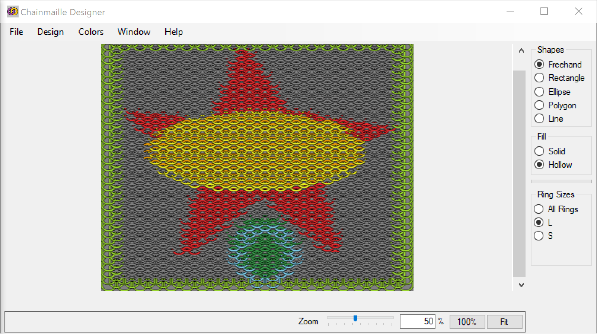

Shape painting: here we have a solid red star-shaped polygon (all rings), a solid yellow ellipse (all rings) overpainted with a solid orange ellipse (small rings only), a solid green circle (all rings) overpainted with a hollow blue circle (large rings only), all framed by a hollow lime-green rectangle (large rings only).

### When Shape Painting is Complete

After the definition of a shape has been completed, the actual painting begins, behind the scenes. Lines and hollow shapes are generally completed fairly quickly, but solid fills, depending on the area covered, can take a while to complete. When this is the case, the shape progress bar, just below the fill box, indicates how far along the process is. Once the painting is complete, the newly-rendered image is displayed in the design area.

After painting a shape, the Shapes control is reset to the default Freehand ring-painting mode.

Sometimes, depending on the weave and the exact placement of your clicks, lines or hollow figures can have gaps where the lines or shape boundaries pass between rings without touching them. You can often re-paint a line, using slightly different click locations, to correct this, or you can use the Freehand painting mode to correct any issues ring by ring.

## Outline and Background Colors

From the palette window, you can also change the color with which the rings are outlined (using the Set Outline Color button) or the color of the background of your design (using the Set Background button). Either of these actions will cause the Choose a Color window to appear (see ***Defining Palettes***, below), from which you can specify the corresponding color.

## Zoom and Scroll

### Zoom

Zoom adjustments allow you to focus in on a detail area or to view the entirety of your design. The zoom controls can be found in the lower right corner of the main window. There are five ways to adjust the zoom in Chainmaille Designer.

#### The Zoom Slider

The zoom slider allows zoom adjustment from 1% (on the left end) to 10,000% (on the right). The scale of the slider is logarithmic, with 100% in the center.

Chainmaille Designer limits small zoom factors so that at least a few pixels are shown in the design area, so the zoom slider may not go all the way to its left edge unless you have a large design.

#### The Zoom Entry Window

To use the zoom entry window, simply type your desired zoom over the currently displayed number. The zoom is adjusted as you type.

#### The 100% Button

Clicking the 100% button returns the zoom to the original 100%, scrolled so that the center of your design is in the center of the design area. Note that this doesn’t really mean that the image on the screen is the same size as your finished article will be, unless your monitor happens to be set for the old 72 pixels per inch standard; most modern monitors have much finer resolution than that. It just means that each pixel of the invisibly-maintained rendered image is shown in one pixel of the design area.

#### The Fit Button

Clicking the Fit button adjusts the zoom and scroll so that the entirety of your design is visible in the design area of the main window.

#### The Mouse Wheel

When the mouse cursor is over the design area of the main window, you can use the mouse wheel (if you have one) to zoom in and out. Zooming using the mouse is a little special. The other zoom controls keep the center of the design area in the same position within your design. When you use the mouse to zoom, though, the part of your design that is under the mouse cursor stays in the same place. This allows you to, for example, point the mouse at a detail, then zoom in on that detail without having to also fuss with the scroll bars.

### Scroll

Any time the zoom is such that your entire design can’t be seen, scroll bars appear at the right and/or bottom edges. These work like scroll bars everywhere else: to adjust which portion of your design is displayed, click and hold the mouse on one of the rectangular indicators in the bar and slide it up and down (or left and right). Release the mouse button when you are done with your adjustment.

## Guidelines

You can also set up guidelines to help you in your design work. These appear as horizontal or vertical lines across your entire design space (bright pink by default, so you can’t mistake them for anything else). Using the Design > Guidelines choice of the main menu (see ***Managing Your Designs***, above) you can easily set guidelines to divide up your design into equal parts or set horizontal or vertical guidelines at points you specify with a mouse click.

When guidelines are specified, they become part of your design. When you save your design, the positions of the guidelines are saved in the design file, and when you open a saved design, any guidelines you had at the time the design was saved will be restored. Guidelines will not, however, be printed when you print your design, nor will they appear when you save the rendered image of your design to an image file.

You can use the Design > Guidelines > Hide / Show menu choice to turn the display of guidelines off and on during the course of your work, and when you no longer need them, you can remove them from your design by selecting Design > Guidelines > Clear All.

### Guidelines, Zoom, and Rotation

Guidelines are placed relative to your design. This means that they will touch the same rings regardless of any zooming in and out you do. They also rotate with your design when you rotate it. Be aware that when you place a new vertical or horizontal guideline on a rotated design that it will be vertical or horizontal in your current view of the design.

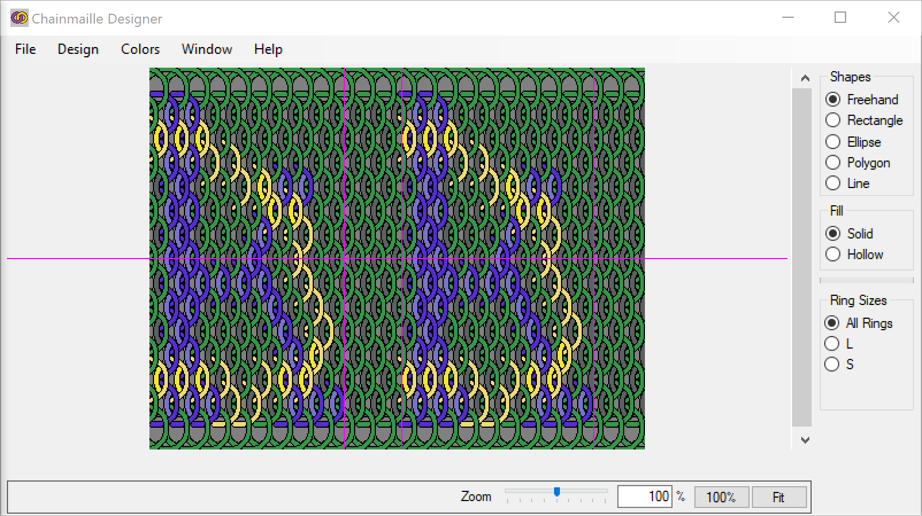

A design with guidelines.

# Overlays

An overlay in Chainmaille Designer is an ordinary image that is displayed semi-transparently over your design. It won’t color your rings for you, but if your subject matter is already available in image form it can be a useful guide to coloring rings.

## Overlay Images

Before you set up an overlay, you must have at least the beginning of a design: a chosen weave and the physical extent (width and height) are the bare minimum. When choosing the size of your design, bear in mind that your rings are your “pixels”. This does **not** mean that you should make your design with as many rings as the original image has pixels. Most images in this day and age have millions of pixels, and I don’t know about you, but I don’t have enough life left that I’m willing to expend it doing nothing but a single chainmaille inlay. Instead consider how many “pixels” you’ll need for the image to be recognizable and, if applicable, the due date for finishing the work.

Once you have something in the design area, open an overlay by choosing Design > Overlay > Open from the menu and choose the image file from amongst the files on your system. Once you’ve chosen the image, it will appear over your design offset and scaled without distortion to its extent.

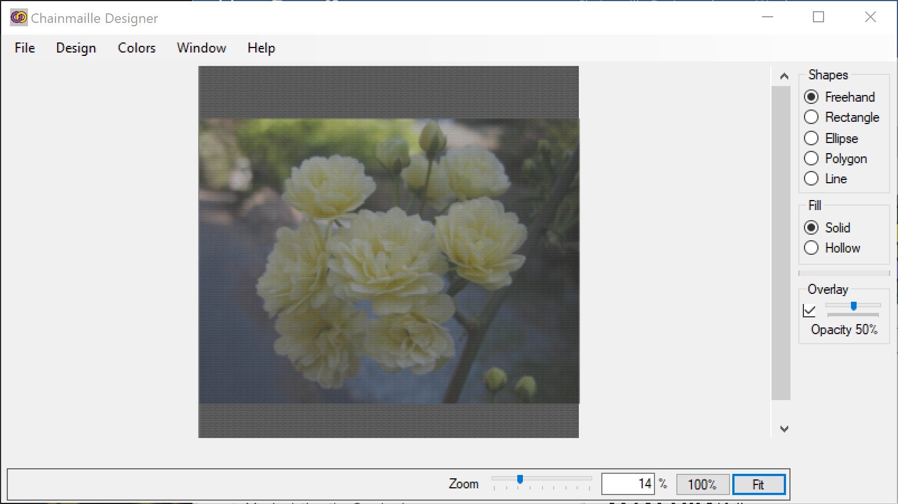  
An image overlay over European 4-1, 200 x 100 units.

To see the whole thing, click on the Fit button in the lower right corner of the window. In the example above, you can see that the proportions of the image don’t match the proportions of the design. In this situation, there are a few basic choices: 1) do nothing; the non-overlaid portions of the design become borders (which can be made fancier if you wish). 2) Ad lib, creating more design to fill the non-overlaid portions of the design. 3) Distort the image (stretching it, in this case) to cover the non-overlaid portions, and 4) Change the size of the design to match the image (in this case, removing units from the top and bottom edges). Changing the size of the design is covered elsewhere, and creating more design is a bit beyond the scope of this simple instruction manual, but stretching, squashing, and repositioning the overlay are all things you can easily do from within Chainmaille Designer.

## Manipulating the Overlay Image

### Rotating the Overlay

If your overlay image is sideways or upside-down for your design, you can use the Design menu to rotate the overlay to the correct orientation in quarter-turn steps. Take care to use the rotation options “inside” the Overlay menu choice; if you use the rotation options at the Design level, it won’t be just the overlay that rotates.

### Stretching, Squashing, and Zooming the Overlay

To begin stretching or squashing the overlay, hold down the control button of your keyboard, then press and hold down either mouse button. As you move the mouse, the overlay image will adjust; becoming larger as you move to the right and/or downward from the point at which you started the operation, or smaller as you move to the left and/or upward from that point.

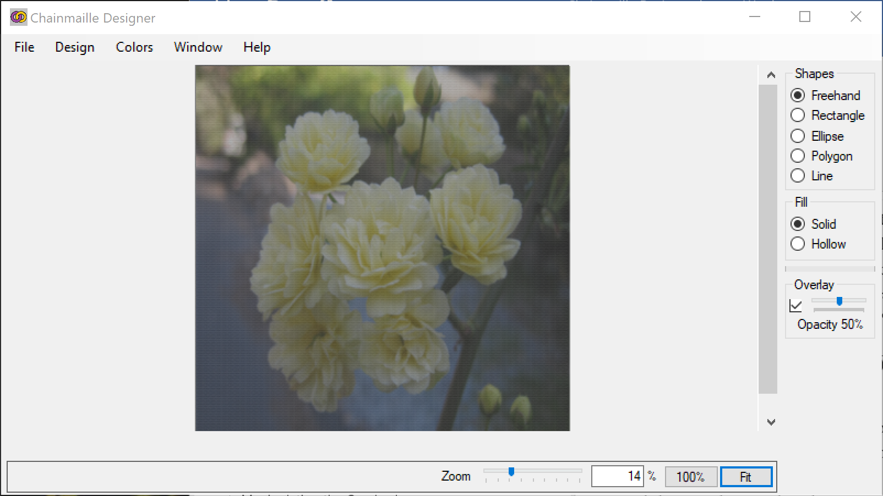  
The overlay image stretched to fit the design size.

Most images can be stretched or squashed a bit without looking too absurd, but some can’t be (images of faces, for example). If you want to make the overlay image larger or smaller without distorting it, use the mouse wheel, as you would for zooming in or out of your design, but while holding the shift key down.

If you’ve been doing this as you’re reading, you’ve probably noticed it already, but rotation, zooming, stretching, and squashing the overlay image all happen with respect to the center of the overlay image; in other words, the center of the overlay image stays in the same place, but the image rotates or gets bigger or smaller around that point. Because the overlay starts out centered in your design, that’s probably what you’ll want most of the time.

### Panning the Overlay

You can, however, also adjust where the overlay image is on your design, also called panning. You do this by holding down the shift key while using the mouse to click and drag. For example, if I particularly liked the flower on the right side of my overlay image, I could use the shift-wheel combination to zoom in to the right degree, then the shift-drag combination to center the desired flower in my design area.

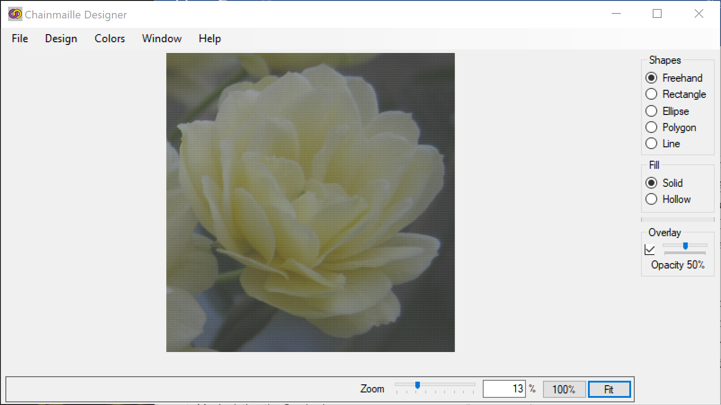  
Overlay zoomed and panned to a single flower.

So, to summarize briefly how to manipulate the overlay image:

* Use the design menu to rotate the overlay.
* Use control-drag to stretch or squash the overlay.
* Use shift-wheel to zoom the overlay in and out.
* Use shift-drag to move the overlay.

## Using the Overlay as a Guide to Painting Rings

Now, you may be thinking, “That’s very pretty, but pasting an image over a drawing of rings isn’t actually a design,” and you’d be absolutely right. To make it a design, you’d want to assign ring colors from your palette to each of the rings of your design. Except for the color-and-shape judgement calls involved, this is a simple matter of painting the rings in the usual fashion, but now you have the overlay to guide you.

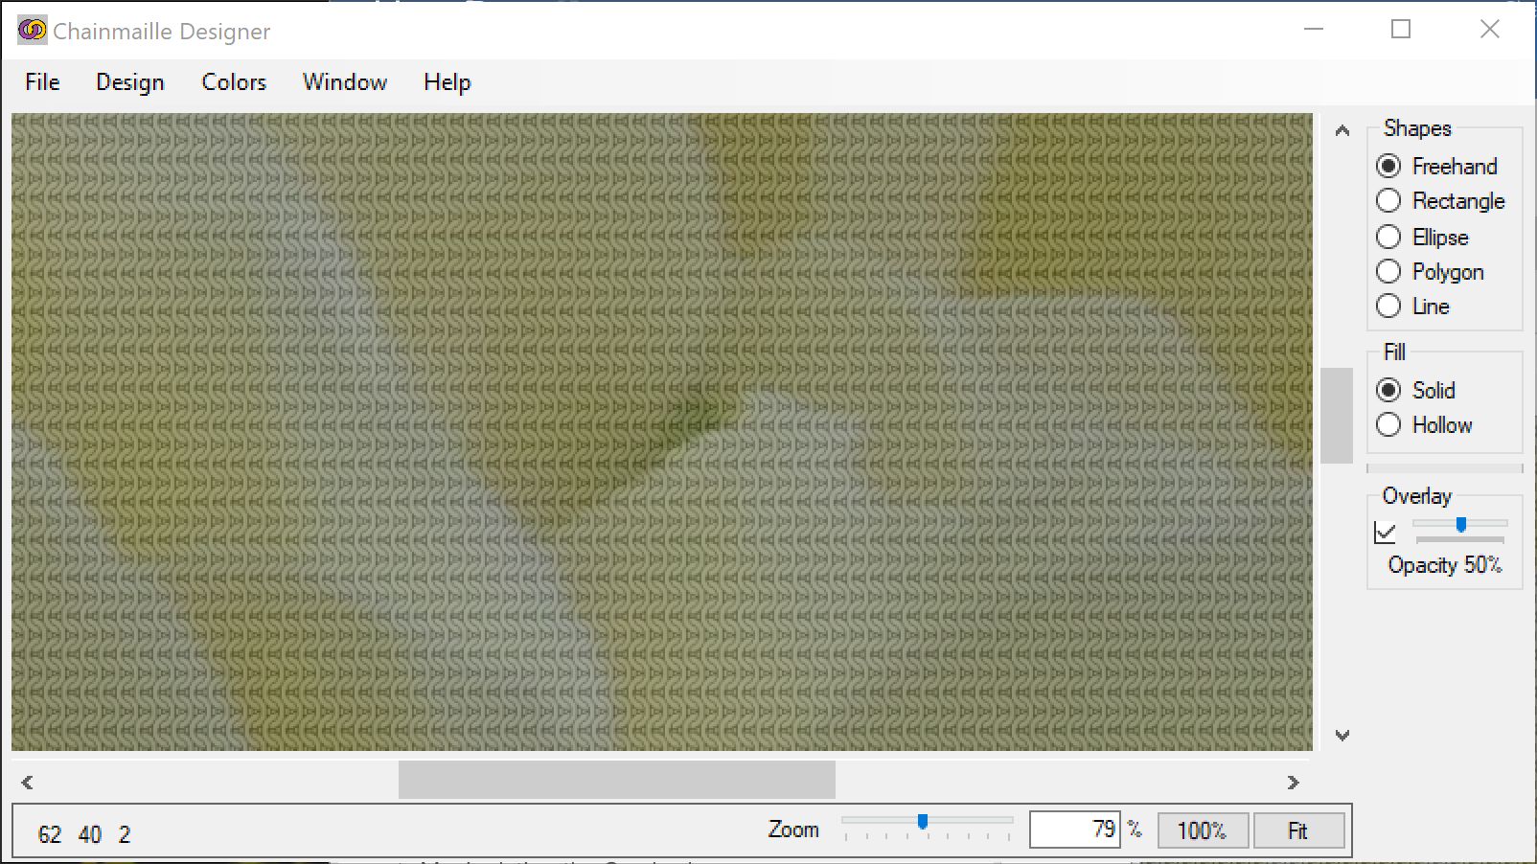  
Overlaid design before painting begins (detail).

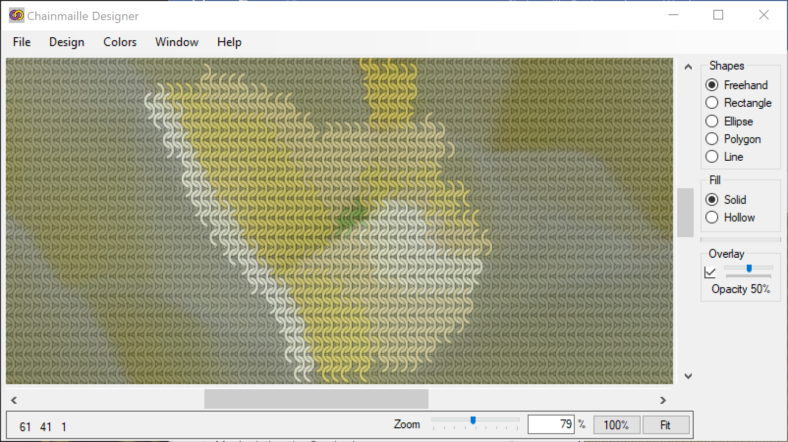  
Overlaid design as painting progresses. This part of the design is mostly gold, champagne, and white rings with a very few green rings.

## The Overlay Control

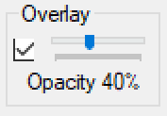As you are painting with an overlay, you may find it handy to periodically hide the overlay to see the effect of your ring color assignments without the overlay image on top. To do this, you can select Design > Overlay > Hide from the menu. To bring a hidden overlay back, select Design > Overlay > Show from the menu. There’s also a keyboard shortcut for this: holding down the Alt key while typing “o” will toggle the overlay on and off. Similar functionality is provided by the checkbox in the Overlay control; checking or unchecking the box will toggle the overlay on and off.

The slider in the Overlay control also allows you to control the overlay opacity as you work, in case the default 50% is not to your taste.

## Coloring Rings from the Overlay

Chainmaille Designer provides a way to jump-start your design by coloring all of the rings based upon the overlay image. It does this by computing the average overlay color within each ring outline, then matching the average color for each ring to the closest color of the palette section of your choice.

Before you start, however, make sure you have loaded a palette and positioned the overlay to your liking, and set the Ring Filter control (if applicable). [Note: If, like me, you use different palette sections for different ring sizes, you’ll have to do the coloring once for each ring size.]

To color the rings in this way, select Colors > Color Rings from Overlay. This bring up a dialog in which you can choose the palette section to use for the coloring, and, if applicable, choose which ring sizes to affect.

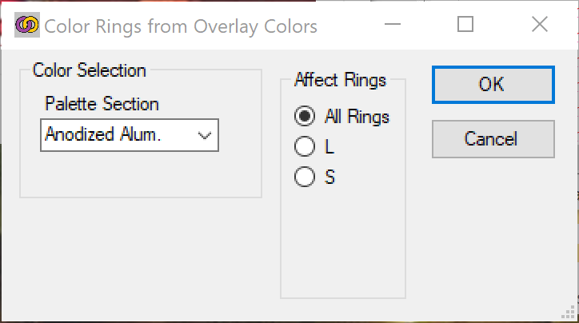

Once you click the OK button, there’s a lot of work going on behind the scenes. The progress bar will show how far along the process is (and with millions of pixels in the overlay image, the process will likely take a while). At the end you’ll be presented with your automatically-colored design.

If you’re really lucky, you’ll be happy with the result. Most of the time, you will not be that lucky. I usually have to perform color replacement (see ***Replacing Colors in Your Design,*** below), followed up by individually painting rings along critical edges and other fine tuning.

For example, here’s an image off of the internet of St. Basil’s Cathedral, and the corresponding automatically colored result.



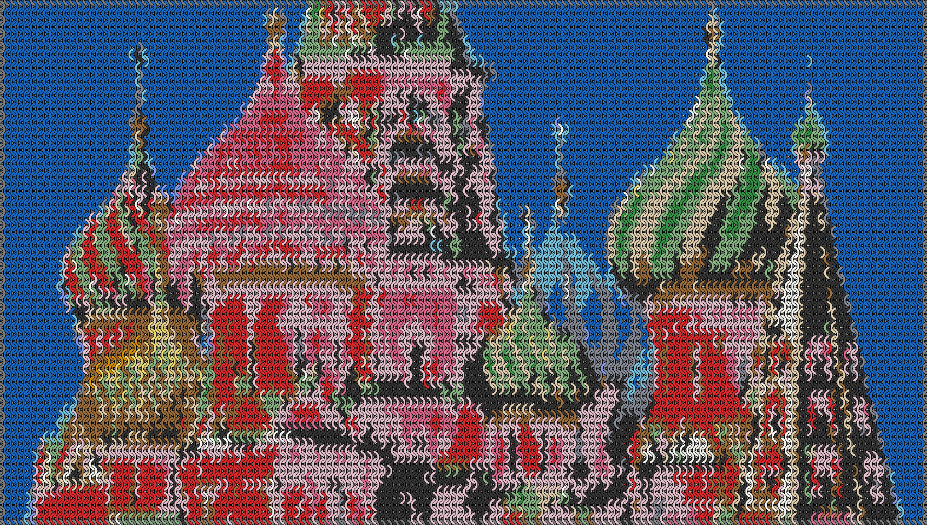

St. Basil’s Cathedral, original image and auto-colored chainmaille design.

The auto-colored result is definitely recognizable, definitely a good start, but it could still use some work. Some changes I would want to make would be to better define the stripes on the red and white dome in front (at least the lower half), extend the colors of all of the other domes into the shadows at their bases, and make the gold bits at the tops of the domes more distinctively gold.

When the palette of the overlay image is already limited, you should expect less immediately-recognizable results. Here’s a picture of me and the auto-colored result.

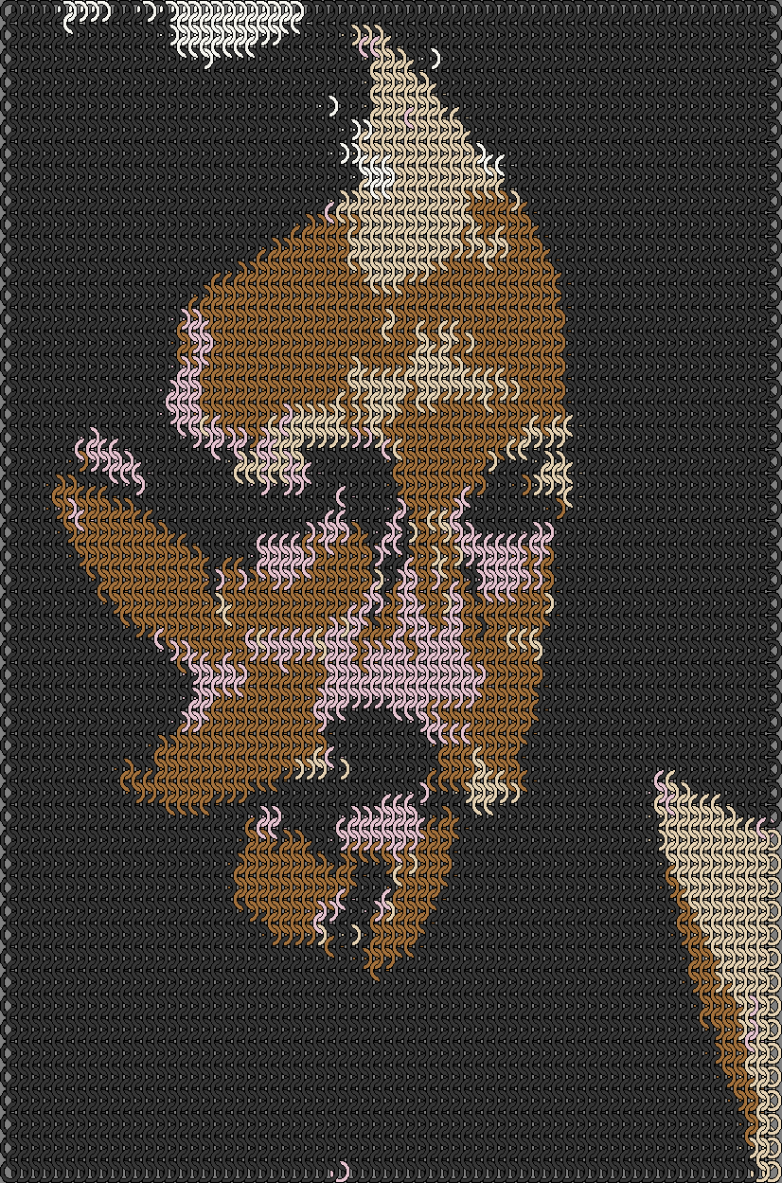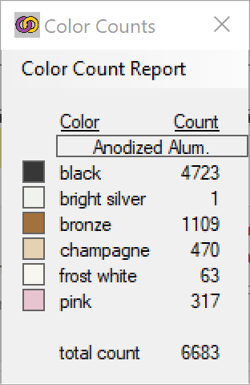

Not so attractive, eh? However, simply replacing the non-black rings with all bronze or all champagne actually improves it. I have often found that having started from a limited-palette original, the way to a better design will be to further limit the palette.

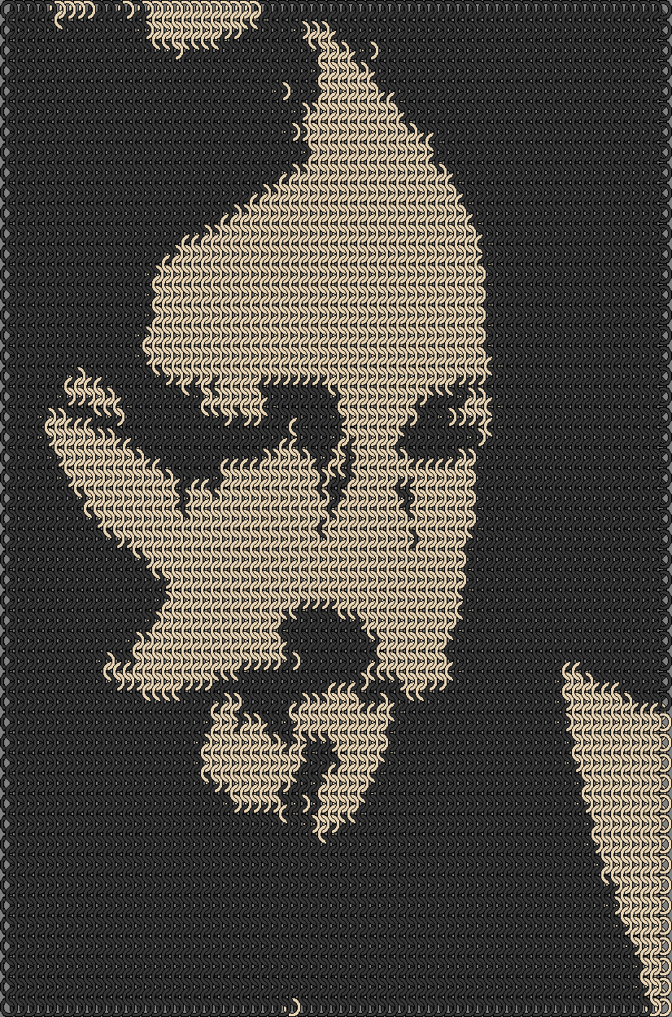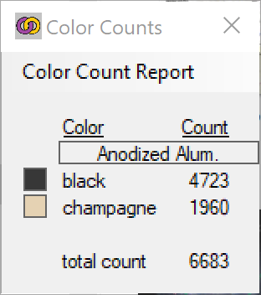

I’d still want to clean up the edges a bit manually, but to get to this point I have spent maybe five minutes and nearly all of the rings have been colored the way I would want them to be.

## The Overlay Image in the Design File

When you save your design, the overlay image file name is saved with the design in the design file, along with the position of the overlay from the corner of your design, the scaling you applied to the overlay (zooming, stretching and squashing), and its rotation (if any). The design file also records whether the overlay was showing when the file was saved and the overlay opacity setting. When you later open your design again, Chainmaille Designer looks for the overlay image file, then applies it over your design so that you can pick up right where you left off.

Of course, this won’t work if you move or delete the overlay image before trying to open your design again, so before applying an image as an overlay I recommend copying it to the design directory so that it will always be with the design. If it can’t find the overlay that goes with your design, Chainmaille Designer will ask you where the overlay image is, but it’s better to avoid trouble than to fix it.

# Counting Colors

## Color Counts

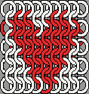The color counter can count how many rings of each color will be needed to build your design and present this in a brief report. This makes it easier to know whether you have enough rings on hand to complete the project or, if not, how many rings of each color you need to order or make. The report also includes the total ring count, which can be useful in estimating how long it will take you to build the project.

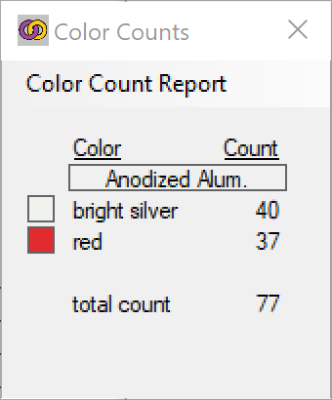Transparent rings (the “unpainted” ones) are not considered part of your design and are not counted in the reported figures.

To count the colors of your design, select Colors > Count Colors from the menu. The Color Counts window will be shown, which summarizes your use of color.

As a very simple example, here are the color counts for the simple heart inlay from the ***Wrap*** section of the chapter on ***Managing Your Designs***.

If your design incorporates ring colors from different palette sections, the color counts are separated by palette section. We’ll use a Dragonscale water bracelet as our example. As you may recall, for these kinds of designs I use aluminum for all of the big rings and rubber for all of the small rings.

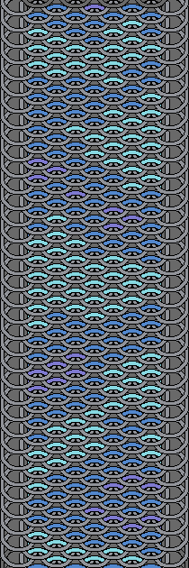  
Dragonscale water bracelet.

Because the palette sections were organized by material, the color report clearly indicates which counts are for metal rings and which counts are for rubber rings.

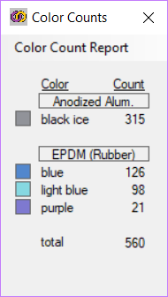

## Detailed Color Report

The color counter can also print or save to a file a detailed report showing exactly how many of which colors need to be put in what order for each row of your design. This can amount to step-by-step instructions (provided you are already familiar with the construction of the weave) for implementing your design.

To obtain the detailed report, select either Print or Save As from the Color Count Report menu at the top of the Color Counts window. Here’s the detailed report for our heart inlay:

Color Count

===== =====

--- Anodized Alum. ---

bright silver 40

red 37

total count 77

row 1: bright silver:9

row 2: bright silver:1 red:2 bright silver:2 red:2 bright silver:1

row 3: red:3 bright silver:1 red:4 bright silver:1

row 4: bright silver:1 red:7

row 5: bright silver:1 red:6 bright silver:2

row 6: bright silver:2 red:5 bright silver:1

row 7: bright silver:2 red:4 bright silver:3

row 8: bright silver:3 red:3 bright silver:2

row 9: bright silver:4 red:1 bright silver:4

## Build Information in Pattern Files

While European 4-1 is straightforward, the correspondence between visual rows in the design and the rows that need to be assembled when building some weaves is not as obvious. For Dragonscale, as an example, the small rings on each row of the visual design must be introduced three rows earlier (further down) when actually building the design.

The row-by-row report produced by the color counter can take account of the discrepancies between the visual design and the way it must actually be built, but only if that information is included in the pattern file that defines the weave. I have done this for Dragonscale as an example (the one named DEDragonscale), but have not added this information to all of the weaves brought forward from the IGP.

# Replacing Colors in Your Design

The color replacement window allows you to quickly change all of the rings of a particular color in your design to any other color. This provides a painless alternative to having to individually re-paint all of the rings of a particular color. There are several reasons why you might wish to do this:

* Change of design; the customer decided they’d like red better than pink.
* Repurposed design; the customer said something like “I’d like one just like the one I saw Jim wearing, but with silver in place of black and with a lighter blue.” or “Could you do something like that in my team’s colors?”
* Starting a design with a color assigned to every ring. By default, rings in a new design are uncolored, but if the inlay will be on a background of bright aluminum rings (for example) it is straightforward to start out a design by setting the color of all of the uncolored rings to that of bright aluminum.
* Change of materials; a design originally made for anodized aluminum colors can be given the closest equivalent colors in titanium or niobium.
* Supplier change; the colors of the original design are no longer available, but the design can be changed to use the colors from the supplier’s most recent palette.
* Upgrade of an old IGP design; each of the standard windows colors in the design can easily be replaced by more accurate ring colors from a defined palette.
* Fixing rings that were accidentally painted using colors from the wrong palette section.

## Replace Colors in Design Window

To perform color replacement in your design, you’ll first need a design (although it could be a new design) and you’ll also want a palette open. To begin, select Colors -> Replace in Design from the main menu. You’ll be presented with the Replace Colors in Design window.

Besides the usual OK and Cancel buttons, this window has four areas.

In the upper left is the Color Replacements area. The left side of this area shows all of the colors in the design, while the right side of this area (once we start working) will show all of the color replacements as we plan them.

The upper middle area shows the colors of one section of the current palette. Replacement colors can be chosen either from these color patches, or you can use the Other Color button to choose any non-palette color. (The Other Color button gets you to the Choose a Color window, described below under ***Defining Palettes, Choose a Color***.) To change which palette section is displayed, choose a different palette section name from the pull-down list box just above the first palette color patch.

The third area, along the bottom, is the preview area. As color replacements are defined, this area shows what your design would look like with the changes.

The fourth area, which is only visible if the chainmaille weave used by the design has more than one ring size, allows the color replacement to be restricted to rings of a certain size. So, for example, I could start with a brand new Dragonscale design and specify that all of the uncolored rings ***that are also small*** should be colored as EPDM black.

For this example, though, let’s start with the fire bracelet we’ve previously seen.

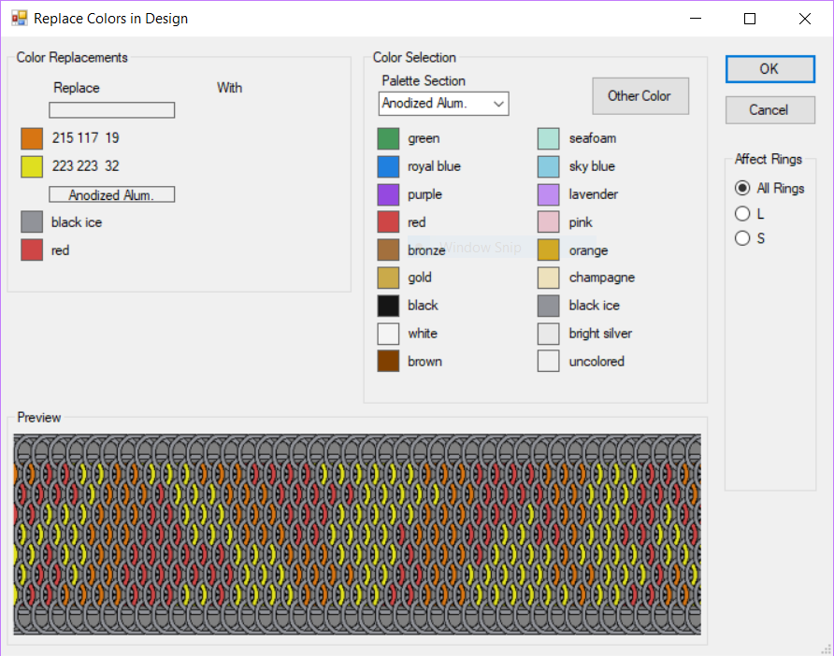

There are a couple of things to notice here. First, there are only four colors, and two of them aren’t from the standard palette (the ones in the blank section, with numbers instead of names). Second, remember that I said that I use rubber rings for the small rings in these designs? And yet, the red rings are colored with the anodized aluminum red, not the EPDM red.

So first I’ll fix these issues to correct the colors of the current design, then I’ll come back to make more substantive changes toward a new design.

## Defining a Color Replacement

To define a color replacement, first click on a color that is to be replaced (either the color patch or the color name, either is fine) in the Color Replacements section. When you do this, the color name will be highlighted to help you remember which color you are working on. Next, click on the color in the Color Selection section that you want to replace it with (or use the Other Color button). When you select a replacement color, the color you picked appears in the right-hand column of the Color Replacement section, opposite the color you’re replacing. You can also observe the effect of the color replacement in the preview area. While a color is selected to be replaced, you can click on any number of replacement colors in succession to try out different substitutions.

To define a replacement for a different color, select that color in the Color Replacements section, and proceed as before.

For example, I’m going to switch to the rubber colors palette (using the drop-down list), then define color replacements for the yellow, orange, and red rings from that palette.

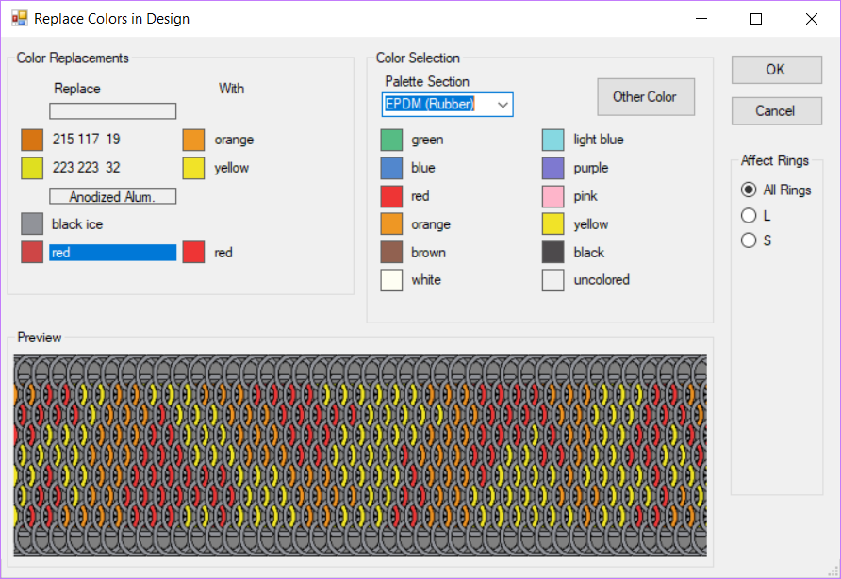

## Effecting the Replacement

As you can see in the preview, the colors are subtly different. To effect the changes, click on the OK button and the colors of the design will be changed.

## A More Dramatic Change

Now, I’m going to go for a more dramatic change, changing the tone of the entire piece to make it more earthy. I’ll replace all of the (newly corrected) rubber colors with other colors from the rubber palette and change the aluminum rings from black ice to bronze.

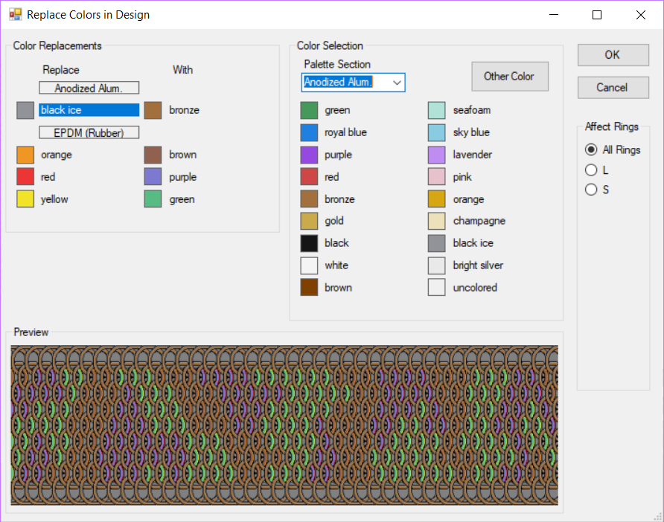

Voila! What looks like a very different piece is just the result of simple color substitutions.

# Defining Palettes

If you wish, you can define your own palettes. There are a couple of reasons why this is a good capability to have. For one, your ring supplier (if you don’t make your own rings) may not be The Ring Lord, so defining a palette of the colors available from your supplier makes excellent sense. Colors can also vary from batch to batch, so editing your palette allows you to adjust the colors used for a particular project to be closer to what you have on hand. Finally, new colors are introduced from time to time (some only temporarily), and colors are occasionally discontinued, so it’s good to be able to adapt your palette as availability changes.

## Editing a Palette

To begin editing an open palette, select Palette > Edit from the menu of the palette window itself (not the main design window). If, instead, you wish to create a new palette, begin by selecting Palette > New from the same menu.

Either way, the Edit Palette window will appear. The top section of this window lets you name your palette and provide a description. The bottom section of the window is where the palette sections are defined.

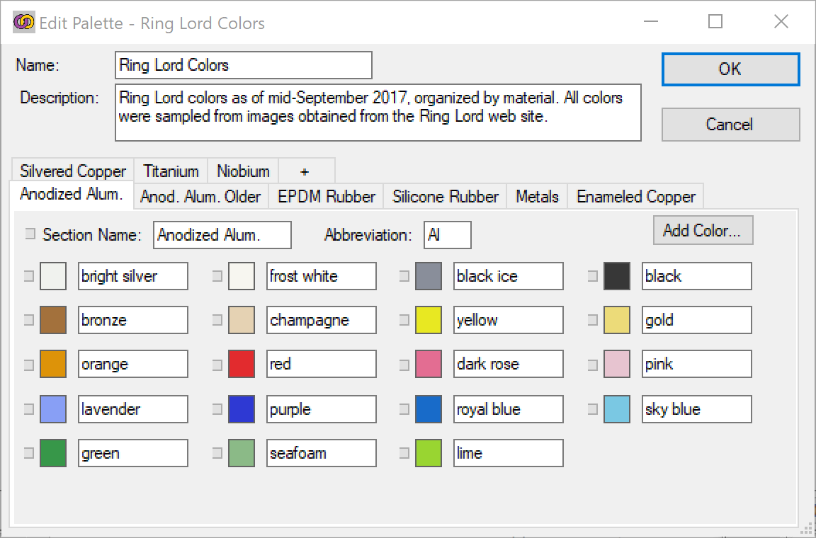

## Editing Palette Sections

Palette sections are mostly for holding a collection of colors, but sections should also be named and given a 2- or 3-letter abbreviation. The section name is displayed in the palette window when you are using the palette (as you’ve already seen). The abbreviation is used in the row-by-row section of detailed color count reports when two colors with the same name (say, “green”) from different sections must be distinguished.

Each palette section is shown in its own tab. To select a palette section for editing, click on its name in the row of tabs.

The last tab, the one with the plus sign (+), is special. Clicking on this tab creates a whole new palette section, which can then be named and have colors added to it.

To delete a palette section, select it for editing, then click on the little square button just to the left of the words “Section Name”. A palette must have at least one section, so you will not be able to delete a section if it is the only section in the palette.

## Editing Palette Colors

To add a color to the selected palette section, click on the Add Color button in the upper right corner of the palette section tab. This causes the Choose a Color window to appear (see Choose a Color, below, for how to use this window). Once a color has been chosen, it is added to the tab area of the selected palette section and can then be named.

Each color of a palette section has a small, square delete button, a larger color patch that shows the actual color, and a text field for entering the name of the color.

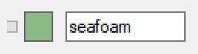

To delete a color from the selected palette section, click on the little square button just to the left of the color patch for the color you wish to delete.

I recommend that you enter a name for each color defined. Color names are useful, especially if you buy your rings from a supplier (in which case, they should be the name that the supplier gives the color to help you when you order rings). They are used in the color report (which can tell you how many rings of each color you need for your design) and they also appear as “hint text” when you hover over a color patch in the palette window.

To set or change a color in the selected palette section, click on the color patch that shows the color. When you do this, the Choose a Color window appears, from which you can change the color you clicked on.

## Choose a Color

The Choose a Color window allows you to specify a color in several different ways.

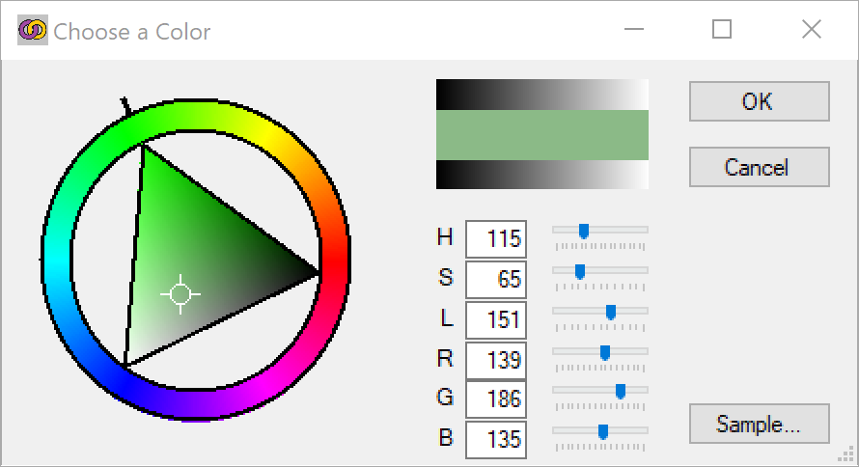  
Choose a Color window, invoked for the “seafoam” color.

There are four main areas of the window. On the left is a tool which allows you to specify a color graphically. The top middle area just shows the selected color against a neutral gradient (from black, through grey, to white) so you can get an idea of what it will look like against a variety of backgrounds. Below that, the components of the color are shown. On the right are the buttons.

### Using the Color Tool

The color tool provides a graphic representation of the hue, saturation, and luminance components of the color.

The outer ring is the hue circle, showing the entire range of available hues (these start with red on the right, then cycle around through yellow, green, blue, and violet before returning to red). On the outside of the ring is a tick mark indicating which of the hues has been chosen. To choose a hue, click either within or outside the ring. You can also click and drag, but this can be a bit slow; it takes a while to fill the triangle with the entire range of colors at a particular hue.

The triangle shows the range of colors available at the selected hue. A white cursor in the triangle shows the combination of saturation and luminance for the chosen color. The most saturated colors are in the corner of the triangle closest to the hue indicator. Moving away from full saturation, colors become either more white or black (in the other two corners) or more grey (on the side opposite the saturated corner). To choose a combination of saturation and luminance for the selected hue, click within the triangle.

### Specifying Color Components

You can also specify the hue, saturation, and luminance components of the color either numerically (in the boxes labeled with H, S, and L, respectively) or by using the slider controls to the right of the boxes.

If you must, you can also specify the color as a combination of red, green, and blue components using the boxes or sliders labeled R, G, and B. While this way of specifying colors is incorrect for colors that arise from reflectance (as ring colors do), a surprising number of people, ignorant of the nature of color, can only think of colors in this way.

### Sampling a Color from an Image

As an alternative to trying to match a ring color either graphically or numerically, you can sample the color from a picture of the rings. While pictures are not always faithful representations of colors, picking a color from an image can be very convenient, so I have tried to make it easy to do.

To sample a color from an image, begin by clicking on the Sample button in the lower right corner of the Choose a Color window. This brings up a file selector with which you can select the image that contains the color you want.

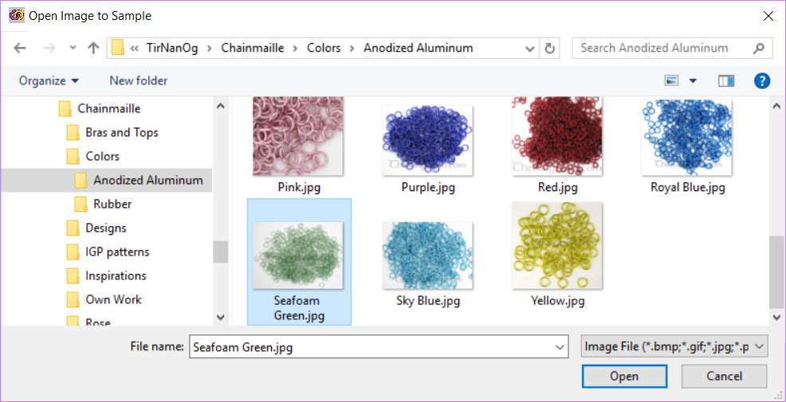

Selecting the image file, then clicking the Open button, shows the selected image in the sampling window.

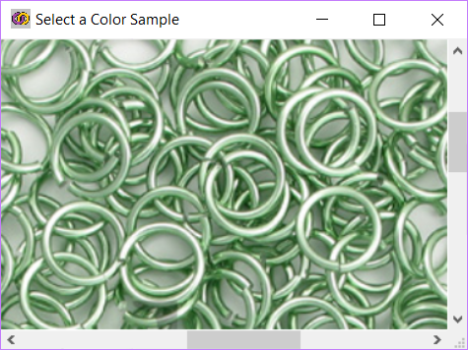

In this window, you can use the mouse wheel to zoom in and out and use the scroll bars to show the portion of the image you wish to sample from. When you’re ready, use the mouse to take a color sample from the image. You can do this in one of two ways.

* **Left** Button – Take a sample from a 5 x 5 pixel area of the image and average the results by clicking on the desired sample area with the left mouse button. This is useful for good-resolution images like the one in our example, where you want a color that represents the visual impression of what is really a range of colors.
* **Right** Button – Take a sample from a single pixel of the image by clicking on the desired sample area with the right mouse button. This is useful for lower-resolution images where using a 5 x 5 area runs the risk of including outline or background pixels in the average.

When you have taken your sample, you will be presented with a confirmation window which displays the sampled color.

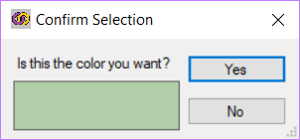

If the color doesn’t seem quite right, you can click the No button, which will return you to your selected image, from which you can take a different sample.

Otherwise, click the Yes button. This will return you to the Choose a Color window with the color of your color sample selected.

### When You Are Done with a Color

When a color is chosen to your satisfaction, click the OK button of the Choose a Color window. The chosen color replaces the color you selected to edit in its palette section.

# Weave Patterns

The pattern information for each weave available within the program is contained within a single directory located within the configured weaves directory. Each weave pattern directory contains a weave pattern file, either in the newer XML format or in the old .ini file format, that specifies how to create the weave pattern. The weave pattern file refers to various image files for the ring outlines and fills, and all of these image files must also be present in the weave pattern directory.

## Sheets and Rings

Each weave pattern definition specifies the ring outlines and ring images for the ring shapes that are used to depict the sheet of the weave, how to put those images together to render a picture of one unit of the weave, and the positions of successive units.

For a very simple weave like European 4-in-1, only 3 images are required for the sheet:

* An outline image – A black on white image of the outlines of the rings as they appear in the sheet. The outline image must be tiling; in other words, fit edge to edge the outline image must be able to depict an arbitrarily-large section of the weave sheet.
* A left ring image – A black on white image of a left-facing ring.
* A right ring image – A black on white image of a right-facing ring.

    
Outline and ring images for European 4 in 1 sheet.

## Edges, Corners and Wrapping

A weave pattern may also specify the particular appearance of the edges and corners of the sheet.

At present, only rectangular edges and corners are supported by the program. An edge is specified as being either top, bottom, left, or right. Corners are specified as being either top left, top right, bottom left, or bottom right. Each edge and corner is specified like the sheet with a tiling outline image and one or more ring images.

|  |  |  |
| --- | --- | --- |
|  |  |  |
|  |  |  |
|  |  |  |

Edge and corner outlines for European 4 in 1, with the sheet in the middle.

When a weave pattern specifies edges and corners, the wrap of the design determines which of the edge and corner definitions are used when rendering the design.

* **No Wrap** – The design is a flat sheet. All edges and corners are used for rendering.
* **Horizontal Wrap** – The design is a continuous horizontal band which has only top and bottom edges.
* **Vertical Wrap** – The design is a continuous vertical band which has only left and right edges.

## Scales

A weave pattern may also specify the sizes of rings to use for the weave and, for each size (or set of sizes) may also specify how many units per inch (or centimeter) the resulting sheet will have vertically and horizontally. For example, the DEDragonscale weave specifies 16G 5/16 rings for the large rings and 18G 3/16 rings for the small rings, and provides the information that with these sizes of rings, there will be 2.18 units per inch horizontally and 6.0 units per inch vertically.

<Scales>

<Scale>

<Measure unitsHorizontal="2.18" unitsVertical="6.0" referenceUnit="inch"/>

<RingSizes>

<RingSize name="L" idinches="5/16" gauge="16" ar="5.2"/>

<RingSize name="S" idinches="3/16" gauge="18" ar="4.1"/>

</RingSizes>

</Scale>

</Scales>

A weave pattern may specify any number of scales. In particular, you can add your favorite scales to any weave pattern that you use by assembling the necessary measurements, then using any competent text editor to add one or more Scale sections to the Scales collection of the weave pattern file. See the appendix of file formats for the details of what each of the tags and attributes means.

## Available Weaves

The weave patterns distributed with this program include a sampling of some of the most popular sheet weaves used for inlay work as well as a few oddballs (such as the knitting templates) and the more universally-applicable hexagonal grids.

|  |  |  |  |  |  |  |
| --- | --- | --- | --- | --- | --- | --- |
| Appearance | Name | Weave | Source | Ring Sizes | Has Edges & Corners | Has Distance Scaling |
|  | DEDragonscale | Dragonscale | Dragon Enchained | 1 pair | Yes | Yes |
|  | DE-Euro4in1 | European 4 in 1 | Dragon Enchained | 1 | Yes | No |
|  | DragonScaleGA16 | Dragonscale | IGP | 1 pair | No | No |
|  | E4-1GA1438 | European 4 in 1 | IGP | 1 | No | No |
|  | E4-1GA1614Half | European 4 in 1 | IGP | 1 | No | No |
|  | E4-1GA1614Right | European 4 in 1 | IGP | 1 | No | No |
|  | E4-1GA1614Wrong | European 4 in 1 | IGP | 1 | No | No |
|  | E4-1GA16316 | European 4 in 1 | IGP | 1 | No | No |
|  | E4-1GA16316Wrong | European 4 in 1 | IGP | 1 | No | No |
|  | E4-1GA16516Right | European 4 in 1 | IGP | 1 | No | No |
|  | E6-1GA16516 | European 6 in 1 | IGP | 1 | No | No |
|  | E6-1Wrong | European 6 in 1 | IGP |  | No | No |
|  | HexLarge | Hex grid | IGP | NA | No | No |
|  | HexLargeXO | Hex grid | IGP | NA | No | No |
|  | HexSmall | Hex grid | IGP | NA | No | No |
|  | HexSmallXO | Hex grid | IGP | NA | No | No |
|  | HP3in1s5in1Horz | Half-Persian, sheet 5 | IGP | 1 | No | No |
|  | HP3in1s5in1Vert | Half-Persian, sheet 5 | IGP | 1 | No | No |
|  | HP3in1s6in1Horz | Half-Persian, sheet 6 | IGP | 1 | No | No |
|  | HP3in1s6in1Vert | Half-Persian, sheet 6 | IGP | 1 | No | No |
|  | HP3n1-S6 | Half-Persian, sheet 6 | IGP |  | No | No |
|  | HP3n1-S6LH | Half-Persian, sheet 6 | IGP |  | No | No |
|  | HP3n1-S6Vert | Half-Persian, sheet 6 | IGP |  | No | No |
|  | HP3n1-S6VertLH | Half-Persian, sheet 6 | IGP |  | No | No |
|  | J4-1GA1638GA1614 | Japanese 4 in 1 | IGP | 1 pair | No | No |
|  | J4-2GA1638GA1614 | Japanese 4 in 2 | IGP | 1 pair | No | No |
|  | J4-3GA1638GA1614 | Japanese 4 in 3 | IGP | 1 pair | No | No |
|  | J6-2GA1638GA1614 | Japanese 6 in 2 | IGP | 1 pair | No | No |
|  | KnitLarge | Rectangular grid | IGP | NA | No | No |
|  | KnitSmall | Rectangular grid | IGP | NA | No | No |
|  | Scale | Scales | IGP | NA | No | No |
|  | trinity1614 | Trinity | IGP | 1 | No | No |

## Decoding IGP Weave Names

As you no doubt noticed in the preceding table, the IGP weave names are often unnecessarily cryptic. Their creators, following Zlosk’s example, tried to pack too much information into the name: not only the name of the weave but also the thickness and diameter of each of the ring sizes used.

### Weave

The abbreviated weave name is the first part of the IGP weave name:

* E4-1 – European 4-in-1
* E6-1 – European 6-in-1
* HP – Half-Persian. 3-in-1 (3n1, 3in1 in the weave names). The two principal half-Persian sheet weaves are sheet 5 and sheet 6 (s5 and s6 in the weave names).
* J – Japanese. The two kinds of sheet are 4 in 1/2/3 or 6 in 1/2/3, where the second number is the number of rings in each set of connecting rings.

### Gauge

Gauges for ring sizes are abbreviated GA, followed by the gauge number. GA16 in the name, for example, means that the rings were made from 16-gauge wire.

### Inner Diameter

Inner diameter for ring sizes in inches are used in the names as just the numerator followed by the denominator without an intervening symbol. The denominator is always a power of two. For example, 316 means that the rings have an inner diameter of 3/16 of an inch.

### Putting It All Together

Putting it all together, J4-2GA1638GA1614 is a Japanese 4-in-2 weave using the two ring sizes of 16-gauge, 3/8 inch inside diameter and 16-gauge, 1/4 inch inside diameter.

### Avoiding Such Nonsense

The new weave file format has a special Scales section for this information, and the designer shows it in a special column in the Choose a Weave window’s list view, features that I put in specifically to get away from this ridiculous overloading of the file names.

It was really quite absurd anyway. E4-1GA16316 specified the exact size of 16G 3/16 rings, but the pattern looks exactly the same for any ring size with an AR of about 3.1: 20G 3/32, 19G 1/8, 18G 9/64, and 14G 1/4, to name a few. It would have made a lot more sense to just call it something like European 4-1 AR31.

## Organization of Weave Patterns

As I mentioned in the ***Directories and File Organization*** chapter, you can organize your weave patterns however you like inside of the configured weaves directory. As installed, though, the weaves used by Chainmaille Designer are organized into the following groups.

**Cells** – This directory contains patterns for things that are not chainmaille weaves such as the various hex grids and the rectangular grids that have Knit in their names.

**European** – This directory contains patterns for various flavors of European 4-in-1 weave as well as weaves structurally related to the European 4-in-1: 6-in-1, the older Dragonscale, and Trinity.

**Japanese** – This directory contains patterns for a few Japanese weaves.

**Persian** – This directory contains patterns for half-Persian 3-in-1 weaves, including various orientations of sheet 5 and sheet 6.

In addition, there are three patterns directly under the configured weaves directory.

**DEDragonscale** – A much-improved Dragonscale weave pattern which includes edges and corners as well as scaling and build information.

**DE-Euro4in1** – An improved version of European 4-in-1 which includes edges and corners.

**Scale** – A pattern for weaves in which metal scales are linked together with chainmaille rings to form a sheet with a very distinctive look. These scales are sold ready-made in colors by The Ring Lord and other suppliers.

# IGP and Chainmaille Designer

Even though I view Chainmaille Designer as a successor to Zlosk’s IGP, this shouldn’t be interpreted too literally. IGP was written in Visual Basic, on a very early version of Microsoft’s .NET framework. Chainmaille Designer is written in C#. Those of you who have a programming background will already have inferred what I am about to state explicitly: not one speck of the IGP source code could be reused in Chainmaille Designer.

What I did instead was to re-use the *concepts* of IGP and produce entirely new implementations of IGP *functionality*, then I went further, providing new concepts and new functionality (guided both by Zlosk’s published list of features he would like to have implemented and by those aspects of using IGP that I found most frustrating).

In this context, it is worthy of mention that a web version of the original IGP has been developed by Andrew Ganim in Javascript. The web IGP is available through Lost Senses Designs (<http://www.lostsensesdesigns.ca/cigp>). While I don’t agree with Andrew’s published assertion that the best thing about IGP is that it “doesn't specifically care about building chainmail” (and have gone to great lengths to make Chainmaille Designer specifically *more* useful for actually building chainmaille), his work has done everyone the service of making IGP accessible to users of UNIX and Macs and, presumably, mobile phones.

## Important Differences between IGP and Chainmaille Designer

A design is more than just an ordered collection of colors. Using IGP, the only way in which your design could be saved was as a simple sequence of colors in image file format. It didn’t even remember which weave you were using for that design. The design files of Chainmaille Designer maintain your weave selection, the sizes of rings you decided to use, whether the design wraps from edge to edge, and will even keep track of when and for whom the design was created.

Colors are important in inlay work! Unless you are anodizing or enameling your rings yourself, there is a limited number of colors available with which to execute your design, and they are NOT Windows-standard red, green, blue, etc. Also, the best way to specify colors is NOT as red-green-blue triples, and certainly not with the standard Windows color picker. Chainmaille Designer lets you save collections of colors as palettes and retrieve them for use in your designs, and it provides a color picker that not only has a clue about colors but allows you to sample your colors from pictures of rings provided by your supplier. IGP didn’t even remember what colors you were using from one session to the next.

Printing is a thing. Not very many people have their computer open in front of them as they build something out of chainmaille. (For one thing, it just doesn’t look good at SCA events.) IGP made you save the rendered image of your design to an image file, then use some *other program* to open and print the image file (and the same thing for the color report, but it had to be a *different* other program because, text). Chainmaille Designer lets you print directly from the Designer.

Real designs have edges and corners. Pretending that designs take place in an infinite sheet might have been a good first approximation for what was, essentially, a class project, but (as the DEDragonscale and DE-Euro4in1 weaves distributed with this program show) it’s possible to do much better, enhancing the ability to visualize what the design will actually look like when it is executed by accurately representing the interactions of the rings at the edges and corners.

Did we say “infinite sheet”? Ah, but it wasn’t infinite, was it? Ever tried to change the size of your IGP design? It couldn’t actually be done in IGP. Instead you had to open up the color image in an imaging program (there’s that *other program* again) to add just the right number of pixels to the edges, which, by the way, required knowing how your chosen weave used the color image, which you could only know by reading and actually understanding the .ini file that defined the weave. Because Chainmaille Designer treats your design *as a design* instead of a bunch of pixels it’s very easy to add or subtract chainmaille units from any of the edges of your design.

Then there’s zoom. When IGP came out it showed the designs in more-or-less actual size (that old 72 pixels per inch standard; remember that? No? Well *I’m* old enough to). As monitors acquired higher and higher resolutions, those IGP graphics got smaller and smaller on the screen, and it got harder and harder to paint the rings you were trying to paint. There were also issues at the other end of the scale: have you ever designed a chainmaille dress in 3/16-inch rings using IGP? I have. Trouble was, I could never see the whole thing because IGP didn’t let me zoom out. Chainmaille Designer fixes those issues for the designer by allowing zoom from 1% to 10,000%, with a special button to quickly return to 100% and another one to fit the entire design within the design area.

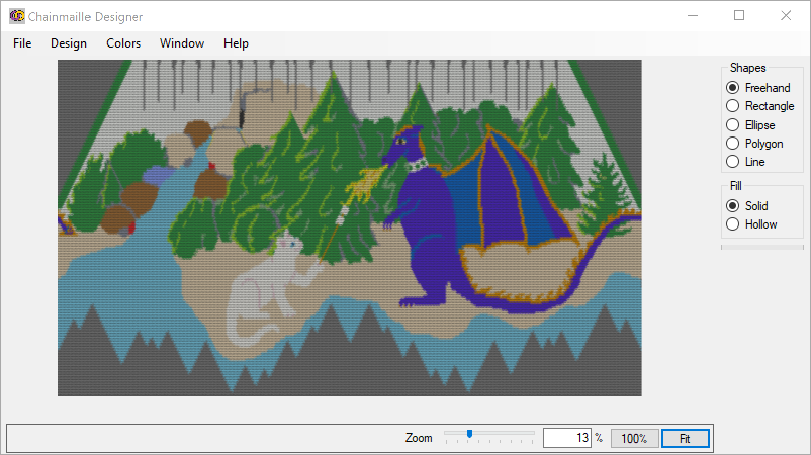  
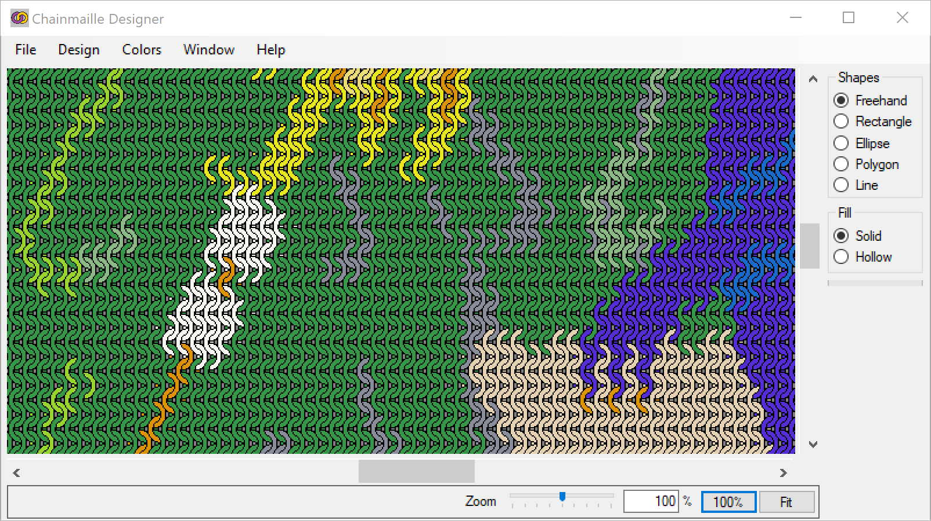  
Chain dress design, with a detail of the marshmallow roasting.  
(Hmm. Can I really call it a detail if it’s only 100 %?)

## IGP Functionality Implemented in Chainmaille Designer

Briefly, these are the capabilities of IGP that I also put into Chainmaille Designer.

* Create a new design with a specified color image size in pixels.
* Open an existing color image, prompting to save if the current design has been changed.
* Save the design with its current name.
* Save the design as a file with a different name.
* Save the rendered image to an image file, specifying the file name and image format.
* Close the current design, prompting to save if the current design has been changed.
* Exit the program, prompting to save if the current design has been changed.
* Apply a weave pattern to the current design and display the rendered image.
* Indicate in the status bar which ring the mouse is over in the zoomed image (row, column, and element).
* Set left button color
* Set right button color
* Paint rings on mouse click of either the left or right button using the color assigned to that button.
* When the mouse button is being held down while the mouse is being moved, continue painting in the color assigned to the button.
* Set background color
* Set outline color
* Show / hide the palette panel using the Window menu.
* Help about
* Count colors and show the number of rings of each color and the total number of rings in a window.
* Save color counts to a text file, appending row length encodings for each row of the design.

## Functionality New to Chainmaille Designer

Nearly as briefly, these are the capabilities I added to Chainmaille Designer above and beyond what was available in IGP. With Chainmaille Designer, you can:

### Zoom

Zoom in or out without using more memory.

Control zoom by

* Typing in a zoom factor (%)
* Using a slider (zoom factor from 0.01 to 100, default 1, logarithmic scale)
* Using a reset button to return to 100%, centered in the center of the rendered image.
* Using a Fit button to fit the entire design into the display area.
* Using the mouse wheel, centering the zoom at the mouse position.

### New Designs and Design Editing

Define the components of a chainmaille design and design an XML file format capable of representing the design information. Allow designs to be saved and read in this format.

Allow design name and weave to be specified when creating a new design.

Provide a form that shows information about the design:

* Name of the design
* Weave name
* Size (width & height in selectable units)
* Date
* Who or what the design is for (i.e. client or recipient)
* Who or what created the design (i.e. personal name or business name)
* Other descriptive information (design notes, etc.)

Change the size of an existing design, adding units or distance to any combination of edges.

Use actual chainmaille units in size specifications (not pixels in the color map), i.e. rows and columns of units.

Use distance measurements in size specifications (at least inches and centimeters). This maps back to ring size, obviously, so depends on the size of rings in which a pattern will be woven.

Instead of making the user drill down through many layers of menus to choose a weave as IGP did, find all weaves in the configured weave directory and present them in list form for selection.

As an alternative to the list, provide a gallery that presents images of the weaves along with their names. Allow the user to select a weave by double-clicking on its image.

When reading an indexed-color color image, convert it into a 32bppARGB bitmap.

Provide the ability to specify rings as not there (making them transparent) for diagonal edges, triangular panels, etc. Transparent rings are not counted by the color counter.

Allow a design to be rotated, so that weaves available in one orientation can be presented in another, and to better fit the available screen dimensions.

Provide a way to specify guidelines for the design to aid in layout.

For weaves of more than one size of ring, allow painting operations to be restricted to rings of only one of those sizes.

Provide a way to paint shapes, i.e. to draw straight lines and to paint either hollow or filled circles, ellipses, rectangles, or polygons to rough in large swatches of color.

### Printing

Print the rendered image to fit the printer page, directly to a printer.

Print the color count report, including row length encodings for each row of the design, directly to a printer.

### Colors, Palette, and Palette Editor

Be able to create named collections (palettes) of colors to use in the designer, e.g. the ring colors available for anodized aluminum rings purchased from The Ring Lord.

Be able to define palette sections, e.g. Anodized Aluminum ring colors vs. EPDM (Rubber) ring colors. Each section can be assigned a name and an abbreviated name (the abbreviated name is used, if needed, to distinguish between colors from different palette sections that have the same color name in the color report.

Define a palette XML file format to save color choices.

Read in palette information from a palette file, prompting to save if the current palette has been changed.

Devise a palette control to use while painting rings that not only shows the current selected colors, but allows selection of any color in the palette. Show the sections, if any.

In the palette control, allow sections to be collapsed (when they aren’t needed) or expanded (if they are).

Tool tips for palette color patches display the name of the color.

Provide a nifty tool for color selection.

Be able to define each color either as HSL or as RGB.

Allow each color to be named, e.g. royal blue, sky blue, seafoam green.

Allow a color to be sampled and averaged from a region of a source image.

Provide a way to replace one color in a design with another color, either from the current palette or specified either as HSL or RGB. For weaves that use more than one ring size, allow color replacement to affect only one ring size, if desired. This allows all of those old IGP designs done in Windows-standard red, green, etc. to be easily recast in colors drawn from the appropriate palette. It also makes it absurdly easy to change, say, a fire-themed design into a water-themed design.

### Color Counting

In the color count window, show patches of each color next to the color name.

In the color count report, substitute the names of colors in the palette for the RGB triples that IGP showed.

In the color count report, substitute system color names (e.g. Alice Blue) for colors that are not named in the palette but for which system colors are predefined.

Make relationship between visual rows and columns and as-built rows and columns more explicit. When preparing the color report, use as-built rows instead of visual rows, if build information is available, so that the report is more useful as build instructions.

In the color report, distinguish between colors from different palette sections that have the same color name, by showing and using the section abbreviated name (e.g. "Anodized Alum. (Al)" ... "EPDM (Rubber) (Rub)", then, when needed in the row portion of the report, appending the section abbreviated name to the color name (e.g. "green(Al): 7").

### Inlay Overlays

Allow an image to be imported to use as a semi-transparent overlay to the ring pattern, as a guide to coloring the rings.

Allow an imported overlay image to be moved, rotated, and squeezed or stretched to cover the design area.

Provide control over the transparency of an overlay.

Automatically use the colors of an overlay image to color the rings of the design, matching the ring colors to the colors available in the palette.

### Weave Specification

Define an XML format for weave pattern files that allows edge and corner images, chain vs. sheet linkage, etc.

Edge graphics for rectangular sheet edges. Corner graphics for corners.

Option to treat edges to wrap around (e.g. for a bracelet), either horizontally or vertically.

Make relationship between chainmaille units and visual rows and columns more explicit. Edges will need to have their own numbers of rows and columns, separate from the main sheet. Use this information when design size is specified.

### Other Features

Provide a configuration form for setting the default directories for weave patterns, image files, designs, palettes, etc.

# Acknowledgements

No software is produced in a vacuum. This program owes its existence to all who have gone before, a long line of mathematicians and computer engineers, and most especially to all computer programmers and developers of computer languages, beginning with Augusta Ada King-Noel, Countess of Lovelace, and continuing through the C lineage left us by Dennis Ritchie, Bjarne Stoustrup and many others.

This particular work owes much of its form and function to Zlosk, the creator of the original Irregular Grid Painter. Chainmaillers everywhere, and I in particular, owe him a debt of gratitude which I hope this program begins to repay. My thanks also to those who contributed pattern files and/or features to the IGP: Tawnos for the Trinity weave, Clawe for European 6-in-1, B Pannell for the knit patterns, MaxumX and Leatherwing for the Persian weaves, and Dunedon for the original color counter.

Celtic_Chainman, MusicMan, Zlosk, and TrenchCoatGuy on the M.A.I.L. forum were particularly helpful with earlier versions of the Chainmaille Designer.

The implementations of the DEDragonscale and DE-Euro4in1 weaves distributed with this program were almost entirely dependent on the skill and persistence of my wife, Elsa DieLöwin. Without her work, the edge and corner treatments of the weave sheets couldn’t have happened.

# Appendix: File Formats

## A Brief Introduction to XML

XML files are ordinary text files with specially-formatted text. There is plenty about them on the internet if you want to know more, but for our purposes it is sufficient to know that an XML file starts with an *XML* *header*. The *header* is followed by one or more *tags*, set off by angled brackets (< >), each of which have any number of attributes (of the form valueName=”value”) and can contain any number of other tags.

There are two ways to delineate a tag, either as a single tag (starting with < and ending with />) or by using a starting tag (<TagName>) and an ending tag (</TagName>) with the contents in between. In the example below, the Color tags are all specified as a single tag, while the other tags are delineated using starting and ending tags.

As an example, here’s the beginning and end of the Ring Lord Colors palette file.

<?xml version="1.0" encoding="UTF-8"?>

<Palette name="Ring Lord Colors" version="1">

<Description>Ring Lord colors as of mid-September 2017, organized by material. All colors were sampled from images obtained from the Ring Lord web site.</Description>

<PaletteSection name="Anodized Alum." abbreviatedName="Al">

<Color name="bright silver" hsl="90 32 226" rgb="240 242 238" />

<Color name="frost white" hsl="51 73 229" rgb="247 246 240" />

<Color name="black ice" hsl="222 19 137" rgb="137 142 154" />

<Color name="black" hsl="0 0 52" rgb="55 55 55" />

<Color name="bronze" hsl="31 111 105" rgb="163 113 60" />

<Color name="champagne" hsl="37 118 192" rgb="229 210 179" />

<Color name="yellow" hsl="60 195 125" rgb="232 232 34" />

<Color name="gold" hsl="51 180 168" rgb="236 219 121" />

<Color name="orange" hsl="39 221 108" rgb="221 147 9" />

<Color name="red" hsl="359 182 127" rgb="226 43 46" />

<Color name="dark rose" hsl="341 163 158" rgb="227 109 146" />

<Color name="pink" hsl="339 101 201" rgb="231 196 208" />

<Color name="lavender" hsl="227 203 179" rgb="136 159 245" />

<Color name="purple" hsl="236 157 121" rgb="46 57 211" />

<Color name="royal blue" hsl="212 189 106" rgb="24 107 201" />

<Color name="sky blue" hsl="195 157 164" rgb="122 200 227" />

<Color name="green" hsl="131 112 97" rgb="55 151 73" />

<Color name="seafoam" hsl="115 65 151" rgb="139 186 135" />

<Color name="lime" hsl="82 159 123" rgb="153 213 49" />

</PaletteSection>

<PaletteSection name="Anod. Alum. Older" abbreviatedName="Alo">

<Color name="black" hsl="160 17 20" rgb="20 23 22" />

<Color name="bronze" hsl="16 82 106" rgb="151 95 74" />

<Color name="gold" hsl="48 110 141" rgb="198 179 101" />

<Color name="yellow" hsl="57 159 114" rgb="201 193 41" />

**...**

</PaletteSection>

</Palette>

Reading the example, the file starts with the XML header. The rest of the file is one big Palette tag. The palette tag has attributes for name and version, a Description tag, and one or more PaletteSection tags. Each PaletteSection tag has attributes for name and abbreviatedName and one or more Color tags. Each Color tag has attributes for name, hsl, and rgb.

**Note: In the following sections, each format description is accompanied by an example file. If you find the descriptions baffling, it will probably help to switch between description and example frequently.**

## Pattern File Format

A pattern file is an XML file which describes how to graphically depict one chainmaille weave. It starts with identifying and descriptive information, then defines how to depict the interior of the sheet. The description of the interior can be optionally followed by descriptions of the edges and corners of the sheet. Additionally, information about ring sizes (or combinations of ring sizes) can be included.

The file starts with a standard XML header. The entire rest of the document is composed of a single mandatory **ChainmailleWeave** tag. The **ChainmailleWeave** tag has the mandatory attributes **name** and **version**, and may optionally have an attribute for **creator**. The **name** is, of course, the name of the weave. The **version** is the version of the pattern file format in which the file was generated. At present, there are two versions, *1* and *2*; only version 2 has the **ringSize** attribute for the **PatternElement** tag and the **name** attribute for the **RingSize** tag. The value of the **creator** attribute is intended to identify the person or organization who created the pattern file.

The **ChainmailleWeave** tag also contains optional tags for **Description** and **PatternImage**, mandatory tags for **UnitVisualSize** and **UnitColorSize**, an optional tag for **EvenRowOffset**, mandatory tags for **Linkage** and **Body**, and optional tags for **Edges** and **Scales**.

The **Description** tag, if present, contains text describing the weave.

The **PatternImage** tag, if present, identifies an image which shows all of the component rings of a portion of the weave in their proper relationships and has the mandatory attribute **file**. The value of the **file** attribute is the file name of the image file, which is assumed to be in the same directory as the rest of the pattern definition components.

The **UnitVisualSize** tag relates units of the weave to visual rows and columns and has the mandatory attributes **rows** and **columns**. The values of the **rows** and **columns** attributes are the number of visual rows and columns, respectively, occupied by a single unit of the weave

The **UnitColorSize** tag relates units of the weave to pixels in a color image and has the mandatory attributes **x** and **y**. The values of the **x** and **y** attributes are the number of pixels, horizontally and vertically, respectively, required to represent the colors of each of the rings in a single unit of the weave.

The **EvenRowOffset** tag, if present, specifies an additional offset in the rendered image to be applied to every even-numbered row of the weave and has the mandatory attributes **x** and **y**. The values of the **x** and **y** attributes are the number of pixels, horizontally and vertically, respectively, by which to offset the drawing elements of the even rows.

The **Linkage** tag specifies the way in which the weave elements connect and has the mandatory attribute **value**. The value of the **value** attribute must be either *sheet* or *chain*. At present, only *sheet* is supported by the program, but the intent is to be able eventually to design color patterns for chains.

The **Body** tag describes how to depict the interior of the sheet and has the mandatory attributes **verticalUnits**, **horizontalUnits**, **rows**, and **columns**. The values of the **verticalUnits** and **horizontalUnits** attributes specify how many weave units vertically and horizontally are being described; typically these are both 1. The values of the **rows** and **columns** attributes specify how many visual rows and columns are spanned by the description; typically this is the same as the unit visual size.

The **Body** tag contains the mandatory **OutlineImage** tag, the optional **PatternSpacing** tag, and the mandatory **PatternElements** tag.

The **OutlineImage** tag identifies a tileable image containing the outlines of the rings of a unit of the weave and has the mandatory attribute **file**. The value of the **file** attribute is the file name of the image file, which is assumed to be in the same directory as the rest of the pattern definition components.

The **PatternSpacing** tag, if present, identifies the spacing between the depiction of one unit and the depiction of the next unit, horizontally and vertically (also subject to the **EvenRowOffset**, if specified) and has the mandatory attributes **x** and **y**. The values of the **x** and **y** attributes are the number of pixels, horizontally and vertically, respectively, by which to offset the drawing elements of successive columns and rows of weave units. If not specified, the size of the outline image is used for the pattern spacing.

The **PatternElements** tag contains one **PatternElement** tag for each ring in its section (whether **Body**, **Edge**, or **Corner**).

Each **PatternElement** tag describes how to depict a single ring and has a mandatory attribute **index**, an optional attribute **ringSize**, and a mandatory attribute **file**. The value of the **index** attribute is a number which identifies the element within its collection of elements, starting with 1. The value of the **ringSize** attribute, if present, is the **name** of the **RingSize** from the **Scale** tags (see below) corresponding to the ring to be used for the element. The value of the **file** attribute is the file name of the image file depicting that one ring, which is assumed to be in the same directory as the rest of the pattern definition components.

Each **PatternElement** also contains mandatory tags for **ImageOffset** and **ColorOffset**, and may contain an optional tag for **BuildOffset**.

The **ImageOffset** tag specifies where to place the upper left corner of the ring image with respect to the upper left corner of the weave unit and has the mandatory attributes **x** and **y**. The values of the **x** and **y** attributes specify the horizontal and vertical offset, in pixels, of the ring image with respect to the weave unit location.

The **ColorOffset** tag specifies where to place the upper left corner of the pixel specifying the color of the ring within the color image with respect to the upper left corner of the weave unit’s position in the color image and has the mandatory attributes **x** and **y**. The values of the **x** and **y** attributes specify the horizontal and vertical offset, in pixels, of the ring pixel with respect to the weave unit pixel block.

The **BuildOffset** tag, if present, specifies the offset, in visual rows and columns, of where the ring must be introduced into the weave during the build process from its apparent position and has the mandatory attributes **x** and **y**. The values of the **x** and **y** attributes specify the number of visual columns and rows, respectively, to offset the element when providing anything like build instructions (such as in the detailed color report). This is not needed for all weaves, but for Dragonscale, as an example, each of the small rings must be introduced into the weave 3 rows further down than where they appear visually in a design.

The **Edges** tag, if present, has a mandatory attribute **geometry**. The value of the **geometry** attribute can be either *rectangular* or *hexagonal* and describes the kind of edges being specified. At present, only *rectangular* edges are supported by the program. The **Edges** tag contains one **Edge** tag for each of the edges appropriate to its geometry and may contain an optional **Corners** tag.

Each **Edge** tag describes how to depict one edge of the sheet and has the mandatory attributes **orientation**, **verticalUnits**, **horizontalUnits**, **rows**, and **columns** and may have the optional attributes **verticalUnitsExtent**, and **horizontalUnitsExtent**. The value of the **orientation** attribute, for rectangular edges, must be either *top*, *bottom*, *left*, or *right*. The values of the **verticalUnits** and **horizontalUnits** attributes specify how many weave units vertically and horizontally are being described. The values of the **rows** and **columns** attributes specify how many visual rows and columns are spanned by the description. The values of the **verticalUnitsExtent** and/or **horizontalUnitsExtent**, if present, give the distance equivalent, in weave units, of the area spanned by the description; otherwise the distance spanned is assumed to be the distance that would be spanned by the number of units specified in the **verticalUnits** and **horizontalUnits** attributes. Each **Edge** tag also contains a mandatory **OutlineImage** tag and a mandatory **PatternElements** tag, the contents of which are just as described previously, under the **Body** tag, except that the outline image depicts the outlines of all of the rings in the edge, which is not necessarily a single weave unit tall or wide.

The **Corners** tag, if present, describes how to depict the corners where the edges of the sheet meet and contains a **Corner** tag for each corner appropriate to the edge geometry.

Each Corner tag describes how to depict a single corner of the sheet and has the mandatory attributes **orientation**, **verticalUnits**, **horizontalUnits**, **rows**, and **columns**. The value of the **orientation** attribute, for rectangular edges, must be either *top left*, *top right*, *bottom* *left*, or *bottom* *right*. The values of the **verticalUnits** and **horizontalUnits** attributes specify how many weave units vertically and horizontally are being described. The values of the **rows** and **columns** attributes specify how many visual rows and columns are spanned by the description. Each **Corner** tag also contains a mandatory **OutlineImage** tag and a mandatory **PatternElements** tag, the contents of which are just as described previously, under the **Body** tag, except that the outline image depicts the outlines of all of the rings in the corner, which is not necessarily a single weave unit tall or wide.

The **Scales** tag, if present, contains one or more **Scale** tags. Each **Scale** tag contains an optional **Measure** tag and a mandatory **RingSizes** tag.

The **Measure** tag, if present, relates chainmaille units to distance units and has the mandatory attributes of **unitsHorizontal**, **unitsVertical**, and **referenceUnit**. The value of the **unitsHorizontal** attribute is the number of chainmaille units that fit horizontally within one reference distance unit. The value of the **unitsVertical** attribute is the number of chainmaille units that fit vertically within one reference distance unit. The value of the **referenceUnit** attribute is the reference distance unit used for each of the previous two measurements, either *inch* or *cm*.

The **RingSizes** tag contains one **RingSize** tag for each ring size needed by the weave. Each **RingSize** tag specifies, for its particular scale, the size of the ring used for the weave and has the mandatory attributes **idinches** and **gauge**, and may have the optional attributes of **ar** and **name**. The value of the **idinches** attribute is the inside diameter of the ring, given in fractional inches, with the numerator and denominator of the fraction separated by a forward slash and the denominator being a positive integral power of 2, e.g. “3/16”. The value of the **gauge** attribute is the thickness (actually the cross-sectional area) of the wire used to make the ring, given as the American Standard wire gauge, e.g. “18”. The value of the **ar** attribute, if present, is the aspect ratio of the ring, given as a decimal number, typically expressed to a precision of one tenth, e.g. “4.1”. The value of the **name** attribute is the abbreviated name of the ring size. I use “VS”, “S”, “M”, “L”, “XL” for “very small”, “small”, “medium”, “large”, and “extra large”, although S and L or S, M, and L suffice for most weaves. These names ought to match the values of the **ringSize** attribute, if present, of each **PatternElement**.

### Example Pattern File

<?xml version="1.0" encoding="UTF-8"?>

<ChainmailleWeave name="DEDragonscale" version ="2" creator="DragonEnchained">

<Description>Dragonscale is structurally equivalent to two interwoven European 4 in 1

sheets. Two ring sizes must be used to make this weave. The larger rings

connect only to smaller rings (not to other larger rings) and vice versa,

of course. The smaller rings' outer diameter must be at least slightly

smaller than the larger rings' inner diameter. When the same wire gauge

is used for both ring sizes in the weave, the minimum AR for the small

rings is about 3.6, and the AR of the large ring must be at least 2.0

higher than that of the small rings (because the small rings must fit

inside the large rings). A more visually interesting effect is created

when the larger rings are also thicker, for example when using 16G 5/16

rings with 18G 3/16 rings.

</Description>

<PatternImage file="DEDragonscale-Sheet-overall.bmp"/>

<UnitVisualSize rows="2" columns="2"/>

<UnitColorSize x="4" y="1"/>

<EvenRowOffset x="0" y="0"/>

<Linkage value="sheet"/>

<Body verticalUnits="1" horizontalUnits="1" rows="2" columns="2">

<OutlineImage file="DEDragonscale-Sheet-outline.bmp"/>

<PatternSpacing x="42" y="18"/>

<PatternElements>

<PatternElement index="0" ringSize="L" file="DEDragonscale-Sheet-LargeRing.bmp">

<ImageOffset x="1" y="1"/>

<ColorOffset x="0" y="0"/>

<BuildOffset x="0" y="0"/>

</PatternElement>

<PatternElement index="1" ringSize="S" file="DEDragonscale-Sheet-SmallRing.bmp">

<ImageOffset x="10" y="5"/>

<ColorOffset x="1" y="0"/>

<BuildOffset x="0" y="3"/>

</PatternElement>

<PatternElement index="2" ringSize="L" file="DEDragonscale-Sheet-LargeRing.bmp">

<ImageOffset x="22" y="10"/>

<ColorOffset x="2" y="0"/>

<BuildOffset x="1" y="1"/>

</PatternElement>

<PatternElement index="3" ringSize="S" file="DEDragonscale-Sheet-SmallRing.bmp">

<ImageOffset x="31" y="14"/>

<ColorOffset x="3" y="0"/>

<BuildOffset x="1" y="4"/>

</PatternElement>

</PatternElements>

</Body>

<Edges geometry="rectangular">

<Edge orientation="top" verticalUnits="3" horizontalUnits="1" rows="5" columns="2" verticalUnitsExtent="2.7">

<OutlineImage file="DEDragonscale-TopEdge-outline.bmp"/>

<PatternElements>

<PatternElement index="0" ringSize="L" file="DEDragonscale-TopEdge-LargeRing-odd.bmp">

<ImageOffset x="2" y="1"/>

<ColorOffset x="0" y="1"/>

<BuildOffset x="0" y="2"/>

</PatternElement>

<PatternElement index="1" ringSize="S" file="DEDragonscale-TopEdge-SmallRing-odd.bmp">

<ImageOffset x="10" y="17"/>

<ColorOffset x="1" y="1"/>

<BuildOffset x="0" y="5"/>

</PatternElement>

<PatternElement index="2" ringSize="L" file="DEDragonscale-TopEdge-LargeRing-even.bmp">

<ImageOffset x="22" y="3"/>

<ColorOffset x="2" y="1"/>

<BuildOffset x="1" y="3"/>

</PatternElement>

<PatternElement index="3" ringSize="S" file="DEDragonscale-TopEdge-SmallRing-even.bmp">

<ImageOffset x="28" y="9"/>

<ColorOffset x="3" y="0"/>

<BuildOffset x="1" y="4"/>

</PatternElement>

<PatternElement index="4" ringSize="S" file="DEDragonscale-Sheet-SmallRing.bmp">

<ImageOffset x="31" y="26"/>

<ColorOffset x="3" y="1"/>

<BuildOffset x="1" y="6"/>

</PatternElement>

<PatternElement index="5" ringSize="L" file="DEDragonscale-Sheet-LargeRing.bmp">

<ImageOffset x="1" y="31"/>

<ColorOffset x="0" y="2"/>

<BuildOffset x="0" y="4"/>

</PatternElement>

<PatternElement index="6" ringSize="S" file="DEDragonscale-Sheet-SmallRing.bmp">

<ImageOffset x="10" y="35"/>

<ColorOffset x="1" y="2"/>

<BuildOffset x="0" y="7"/>

</PatternElement>

<PatternElement index="7" ringSize="L" file="DEDragonscale-Sheet-LargeRing.bmp">

<ImageOffset x="22" y="40"/>

<ColorOffset x="2" y="2"/>

<BuildOffset x="1" y="5"/>

</PatternElement>

<PatternElement index="8" ringSize="S" file="DEDragonscale-Sheet-SmallRing.bmp">

<ImageOffset x="31" y="44"/>

<ColorOffset x="3" y="2"/>

<BuildOffset x="1" y="8"/>

</PatternElement>

</PatternElements>

</Edge>

<Edge orientation="bottom" verticalUnits="3" horizontalUnits="1" rows="5" columns="2" verticalUnitsExtent="3">

<OutlineImage file="DEDragonscale-BottomEdge-outline.bmp"/>

<PatternElements>

<PatternElement index="0" ringSize="L" file="DEDragonscale-Sheet-LargeRing.bmp">

<ImageOffset x="1" y="1"/>

<ColorOffset x="0" y="0"/>

<BuildOffset x="0" y="0"/>

</PatternElement>

<PatternElement index="1" ringSize="S" file="DEDragonscale-Sheet-SmallRing.bmp">

<ImageOffset x="10" y="5"/>

<ColorOffset x="1" y="0"/>

<BuildOffset x="0" y="3"/>

</PatternElement>

<PatternElement index="2" ringSize="L" file="DEDragonscale-Sheet-LargeRing.bmp">

<ImageOffset x="22" y="10"/>

<ColorOffset x="2" y="0"/>

<BuildOffset x="1" y="1"/>

</PatternElement>

<PatternElement index="3" ringSize="S" file="DEDragonscale-BottomEdge-SmallRing.bmp">

<ImageOffset x="31" y="14"/>

<ColorOffset x="3" y="0"/>

<BuildOffset x="1" y="4"/>

</PatternElement>

<PatternElement index="4" ringSize="L" file="DEDragonscale-Sheet-LargeRing.bmp">

<ImageOffset x="1" y="19"/>

<ColorOffset x="0" y="1"/>

<BuildOffset x="0" y="2"/>

</PatternElement>

<PatternElement index="5" ringSize="L" file="DEDragonscale-BottomEdge-LargeRing.bmp">

<ImageOffset x="22" y="18"/>

<ColorOffset x="2" y="1"/>

<BuildOffset x="1" y="3"/>

</PatternElement>

<PatternElement index="6" ringSize="L" file="DEDragonscale-BottomEdge-LargeRing.bmp">

<ImageOffset x="1" y="27"/>

<ColorOffset x="0" y="2"/>

<BuildOffset x="0" y="4"/>

</PatternElement>

</PatternElements>

</Edge>

<Edge orientation="left" verticalUnits="1" horizontalUnits="1" rows="2" columns="2" horizontalUnitsExtent="1">

<OutlineImage file="DEDragonscale-LeftEdge-outline.bmp"/>

<PatternElements>

<PatternElement index="0" ringSize="L" file="DEDragonscale-LeftEdge-LargeRing-odd.bmp">

<ImageOffset x="1" y="-20"/>

<ColorOffset x="0" y="0"/>

<BuildOffset x="0" y="0"/>

</PatternElement>

<PatternElement index="1" ringSize="L" file="DEDragonscale-LeftEdge-LargeRing-even.bmp">

<ImageOffset x="22" y="1"/>

<ColorOffset x="2" y="0"/>

<BuildOffset x="1" y="1"/>

</PatternElement>

<BuildOffset x="0" y="0"/>

<PatternElement index="2" ringSize="S" file="DEDragonscale-LeftEdge-SmallRing.bmp">

<ImageOffset x="31" y="14"/>

<ColorOffset x="3" y="0"/>

<BuildOffset x="1" y="4"/>

</PatternElement>

</PatternElements>

</Edge>

<Edge orientation="right" verticalUnits="1" horizontalUnits="2" rows="2" columns="3" horizontalUnitsExtent="2">

<OutlineImage file="DEDragonscale-RightEdge-outline.bmp"/>

<PatternElements>

<PatternElement index="0" ringSize="L" file="DEDragonscale-Sheet-LargeRing.bmp">

<ImageOffset x="1" y="1"/>

<ColorOffset x="0" y="0"/>

<BuildOffset x="0" y="0"/>

</PatternElement>

<PatternElement index="1" ringSize="S" file="DEDragonscale-Sheet-SmallRing.bmp">

<ImageOffset x="10" y="5"/>

<ColorOffset x="1" y="0"/>

<BuildOffset x="0" y="3"/>

</PatternElement>

<PatternElement index="2" ringSize="L" file="DEDragonscale-RightEdge-LargeRing-even.bmp">

<ImageOffset x="22" y="1"/>

<ColorOffset x="2" y="0"/>

<BuildOffset x="1" y="1"/>

</PatternElement>

<PatternElement index="3" ringSize="S" file="DEDragonscale-RightEdge-SmallRing.bmp">

<ImageOffset x="31" y="14"/>

<ColorOffset x="3" y="0"/>

<BuildOffset x="1" y="4"/>

</PatternElement>

<PatternElement index="4" ringSize="L" file="DEDragonscale-RightEdge-LargeRing-odd.bmp">

<ImageOffset x="43" y="-20"/>

<ColorOffset x="4" y="0"/>

<BuildOffset x="2" y="0"/>

</PatternElement>

</PatternElements>

</Edge>

<Corners>

<Corner orientation="top left" verticalUnits="3" horizontalUnits="1" rows="5" columns="2">

<OutlineImage file="DEDragonscale-TopLeft-outline.bmp"/>

<PatternElements>

<PatternElement index="0" ringSize="L" file="DEDragonscale-TopLeft-LargeRing-odd1.bmp">

<ImageOffset x="1" y="1"/>

<ColorOffset x="0" y="1"/>

<BuildOffset x="0" y="2"/>

</PatternElement>

<PatternElement index="1" ringSize="L" file="DEDragonscale-TopLeft-LargeRing-even.bmp">

<ImageOffset x="22" y="3"/>

<ColorOffset x="2" y="1"/>

<BuildOffset x="1" y="3"/>

</PatternElement>

<PatternElement index="2" ringSize="S" file="DEDragonscale-TopLeft-SmallRing-even.bmp">

<ImageOffset x="27" y="9"/>

<ColorOffset x="3" y="0"/>

<BuildOffset x="1" y="4"/>

</PatternElement>

<PatternElement index="3" ringSize="S" file="DEDragonscale-LeftEdge-SmallRing.bmp">

<ImageOffset x="31" y="26"/>

<ColorOffset x="3" y="1"/>

<BuildOffset x="1" y="6"/>

</PatternElement>

<PatternElement index="4" ringSize="L" file="DEDragonscale-TopLeft-LargeRing-odd2.bmp">

<ImageOffset x="1" y="14"/>

<ColorOffset x="0" y="2"/>

<BuildOffset x="0" y="4"/>

</PatternElement>

<PatternElement index="5" ringSize="L" file="DEDragonscale-LeftEdge-LargeRing-even.bmp">

<ImageOffset x="22" y="31"/>

<ColorOffset x="2" y="2"/>

<BuildOffset x="1" y="5"/>

</PatternElement>

<PatternElement index="6" ringSize="S" file="DEDragonscale-LeftEdge-SmallRing.bmp">

<ImageOffset x="31" y="44"/>

<ColorOffset x="3" y="2"/>

<BuildOffset x="1" y="8"/>

</PatternElement>

</PatternElements>

</Corner>

<Corner orientation="top right" verticalUnits="3" horizontalUnits="2" rows="5" columns="3">

<OutlineImage file="DEDragonscale-TopRight-outline.bmp"/>

<PatternElements>

<PatternElement index="0" ringSize="L" file="DEDragonscale-TopEdge-LargeRing-odd.bmp">

<ImageOffset x="2" y="1"/>

<ColorOffset x="0" y="1"/>

<BuildOffset x="0" y="2"/>

</PatternElement>

<PatternElement index="1" ringSize="S" file="DEDragonscale-TopEdge-SmallRing-odd.bmp">

<ImageOffset x="10" y="17"/>

<ColorOffset x="1" y="1"/>

<BuildOffset x="0" y="5"/>

</PatternElement>

<PatternElement index="2" ringSize="L" file="DEDragonscale-TopRight-LargeRing-even.bmp">

<ImageOffset x="22" y="3"/>

<ColorOffset x="2" y="1"/>

<BuildOffset x="1" y="3"/>

</PatternElement>

<PatternElement index="3" ringSize="S" file="DEDragonscale-TopRight-SmallRing-even.bmp">

<ImageOffset x="28" y="9"/>

<ColorOffset x="3" y="0"/>

<BuildOffset x="1" y="4"/>

</PatternElement>

<PatternElement index="4" ringSize="S" file="DEDragonscale-RightEdge-SmallRing.bmp">

<ImageOffset x="31" y="26"/>

<ColorOffset x="3" y="1"/>

<BuildOffset x="1" y="6"/>

</PatternElement>

<PatternElement index="5" ringSize="L" file="DEDragonscale-TopRight-LargeRing-odd1.bmp">

<ImageOffset x="44" y="1"/>

<ColorOffset x="4" y="1"/>

<BuildOffset x="2" y="2"/>

</PatternElement>

<PatternElement index="6" ringSize="L" file="DEDragonscale-Sheet-LargeRing.bmp">

<ImageOffset x="1" y="31"/>

<ColorOffset x="0" y="2"/>

<BuildOffset x="0" y="4"/>

</PatternElement>

<PatternElement index="7" ringSize="S" file="DEDragonscale-Sheet-SmallRing.bmp">

<ImageOffset x="10" y="35"/>

<ColorOffset x="1" y="2"/>

<BuildOffset x="0" y="7"/>

</PatternElement>

<PatternElement index="8" ringSize="L" file="DEDragonscale-RightEdge-LargeRing-even.bmp">

<ImageOffset x="22" y="31"/>

<ColorOffset x="2" y="2"/>

<BuildOffset x="1" y="5"/>

</PatternElement>

<PatternElement index="9" ringSize="S" file="DEDragonscale-RightEdge-SmallRing.bmp">

<ImageOffset x="31" y="44"/>

<ColorOffset x="3" y="2"/>

<BuildOffset x="1" y="8"/>

</PatternElement>

<PatternElement index="10" ringSize="L" file="DEDragonscale-TopRight-LargeRing-odd2.bmp">

<ImageOffset x="46" y="14"/>

<ColorOffset x="4" y="2"/>

<BuildOffset x="2" y="4"/>

</PatternElement>

</PatternElements>

</Corner>

<Corner orientation="bottom left" verticalUnits="3" horizontalUnits="1" rows="5" columns="2">

<OutlineImage file="DEDragonscale-BottomLeftCorner-outline.bmp"/>

<PatternElements>

<PatternElement index="0" ringSize="L" file="DEDragonscale-LeftEdge-LargeRing-odd.bmp">

<ImageOffset x="1" y="-20"/>

<ColorOffset x="0" y="0"/>

<BuildOffset x="0" y="0"/>

</PatternElement>

<PatternElement index="1" ringSize="L" file="DEDragonscale-LeftEdge-LargeRing-even.bmp">

<ImageOffset x="22" y="1"/>

<ColorOffset x="2" y="0"/>

<BuildOffset x="1" y="1"/>

</PatternElement>

<PatternElement index="2" ringSize="S" file="DEDragonscale-BottomLeftCorner-SmallRing.bmp">

<ImageOffset x="30" y="14"/>

<ColorOffset x="3" y="0"/>

<BuildOffset x="1" y="4"/>

</PatternElement>

<PatternElement index="3" ringSize="L" file="DEDragonscale-LeftEdge-LargeRing-odd.bmp">

<ImageOffset x="1" y="-2"/>

<ColorOffset x="0" y="1"/>

<BuildOffset x="0" y="2"/>

</PatternElement>

<PatternElement index="4" ringSize="L" file="DEDragonscale-BottomEdge-LargeRing.bmp">

<ImageOffset x="22" y="18"/>

<ColorOffset x="2" y="1"/>

<BuildOffset x="1" y="3"/>

</PatternElement>

<PatternElement index="5" ringSize="L" file="DEDragonscale-BottomLeftCorner-LargeRing.bmp">

<ImageOffset x="1" y="16"/>

<ColorOffset x="0" y="2"/>

<BuildOffset x="0" y="4"/>

</PatternElement>

</PatternElements>

</Corner>

<Corner orientation="bottom right" verticalUnits="3" horizontalUnits="2" rows="5" columns="3">

<OutlineImage file="DEDragonscale-BottomRightCorner-outline.bmp"/>

<PatternElements>

<PatternElement index="0" ringSize="L" file="DEDragonscale-Sheet-LargeRing.bmp">

<ImageOffset x="1" y="1"/>

<ColorOffset x="0" y="0"/>

<BuildOffset x="0" y="0"/>

</PatternElement>

<PatternElement index="1" ringSize="S" file="DEDragonscale-Sheet-SmallRing.bmp">

<ImageOffset x="10" y="5"/>

<ColorOffset x="1" y="0"/>

<BuildOffset x="0" y="3"/>

</PatternElement>

<PatternElement index="2" ringSize="L" file="DEDragonscale-RightEdge-LargeRing-even.bmp">

<ImageOffset x="22" y="1"/>

<ColorOffset x="2" y="0"/>

<BuildOffset x="1" y="1"/>

</PatternElement>

<PatternElement index="3" ringSize="S" file="DEDragonscale-BottomRightCorner-SmallRing.bmp">

<ImageOffset x="31" y="14"/>

<ColorOffset x="3" y="0"/>

<BuildOffset x="1" y="4"/>

</PatternElement>

<PatternElement index="4" ringSize="L" file="DEDragonscale-RightEdge-LargeRing-odd.bmp">

<ImageOffset x="43" y="-20"/>

<ColorOffset x="4" y="0"/>

<BuildOffset x="2" y="0"/>

</PatternElement>

<PatternElement index="5" ringSize="L" file="DEDragonscale-Sheet-LargeRing.bmp">

<ImageOffset x="1" y="19"/>

<ColorOffset x="0" y="1"/>

<BuildOffset x="0" y="2"/>

</PatternElement>

<PatternElement index="6" ringSize="L" file="DEDragonscale-BottomEdge-LargeRing.bmp">

<ImageOffset x="22" y="18"/>

<ColorOffset x="2" y="1"/>

<BuildOffset x="1" y="3"/>

</PatternElement>

<PatternElement index="7" ringSize="L" file="DEDragonscale-RightEdge-LargeRing-odd.bmp">

<ImageOffset x="43" y="-2"/>

<ColorOffset x="4" y="1"/>

<BuildOffset x="2" y="2"/>

</PatternElement>

<PatternElement index="8" ringSize="L" file="DEDragonscale-BottomEdge-LargeRing.bmp">

<ImageOffset x="1" y="27"/>

<ColorOffset x="0" y="2"/>

<BuildOffset x="0" y="4"/>

</PatternElement>

<PatternElement index="9" ringSize="L" file="DEDragonscale-BottomRightCorner-LargeRing.bmp">

<ImageOffset x="43" y="16"/>

<ColorOffset x="4" y="2"/>

<BuildOffset x="2" y="4"/>

</PatternElement>

</PatternElements>

</Corner>

</Corners>

</Edges>

<Scales>

<Scale>

<Measure unitsHorizontal="2.18" unitsVertical="6.0" referenceUnit="inch"/>

<RingSizes>

<RingSize name="L" idinches="5/16" gauge="16" ar="5.2"/>

<RingSize name="S" idinches="3/16" gauge="18" ar="4.1"/>

</RingSizes>

</Scale>

</Scales>

</ChainmailleWeave>

## Design File Format

A design file is an XML file describing a single design which starts with identifying and descriptive information, then defines the weave, design size, ring sizes, overlay image (if any) and the image which contains the color assignments for each of the rings in the design.

The file starts with a standard XML header. The entire rest of the document is composed of a single mandatory **ChainmailleDesign** tag. The **ChainmailleDesign** tag has the mandatory attributes, **name** and **version**. The **name** is, of course, the name of the design. The **version** is the version of the design file format in which the file was generated. At present, there are two versions, *1* and *2*; only version 2 has the HiddenSection tags for a Palette tag and the Guidelines tag. The **ChainmailleDesign** tag also contains optional tags for **DesignedBy**, **Date**, **DesignedFor**, **Description**, **Palette**, **DisplayRotation**, **Guidelines**, and (for now) a single mandatory **DesignSection** tag.

The **DesignedBy** tag, if present, contains text intended to identify either the designer (a person) or their organization (the designer’s company or household).

The **Date** tag, if present, contains a textual representation of a date and time.

The **DesignedFor** tag, if present, contains text intended to identify the person or organization for whom the design was produced.

The **Description** tag, if present, contains text describing any additional design-related information that the designer wishes to include.

The **Palette** tag, if present, identifies the palette used with the design and has the mandatory attributes **name** and **file**. The value of the **name** attribute is the name of the palette. The value of the **file** attribute is the full filepath to the palette file.

The **Palette** tag may also optionally contain any number of **HiddenSection** tags. Each **HiddenSection** tag has the mandatory attribute **name**. The value of the **name** attribute is the name of a palette section (see the Palette File Format, below) which was collapsed at the time the design was saved.

The **DisplayRotation** tag, if present, indicates the orientation of the design and has the mandatory attribute **degrees**. The value of the **degrees** attribute is the angle by which to rotate the rendered image of the design (and its overlay, if any) before presenting it to the user in the design area.

The **DesignSection** tag contains mandatory tags for **ChainmaillePattern**, **DesignSize**, and **ColorImage**, and may optionally contain tags for **RingSizes** and **Overlay**.

The **ChainmaillePattern** tag contains the mandatory attributes **name** and **file**. The value of the **name** attribute is the name of the weave used in the design. The value of the **file** attribute is the filepath to the weave definition folder, starting from the configured Weaves directory.

The **DesignSize** tag contains the mandatory attributes **rows** and **columns**, and may optionally contain an attribute for **wrap**. The values of the **rows** and **columns** attributes are the vertical and horizontal extents, respectively, of the design, given in chainmaille units (not in any of the other kinds of size units available within the program). The value of the **wrap** attribute describes the topology of the design, and may only have the values *none*, *horizontal*, or *vertical*. If the **wrap** attribute is not specified, it is assumed to have the value *none*.

The **RingSizes** tag, if present, contains one **RingSize** tag for each of the ring sizes used in the design. Each **RingSize** tag has the mandatory attributes **idinches** and **gauge**, and may optionally contain an attribute for **ar**. The value of the **idinches** attribute is the inside diameter of the ring, given in fractional inches, with the numerator and denominator of the fraction separated by a forward slash and the denominator being a positive integral power of 2. The value of the **gauge** attribute is the thickness (actually the cross-sectional area) of the ring, given as the American Standard wire gauge. The value of the **ar** attribute, if present, is the aspect ratio of the ring, given as a decimal number, typically expressed to a precision of one tenth, e.g. “4.1”.

The **ColorImage** tag identifies the image which contains the color assignments for each of the rings in the design and has the mandatory attributes **name** and **file**. The value of the **name** attribute is the name of the image file. The value of the **file** attribute is the full filepath to the image file.

The **Overlay** tag, if present, identifies the image which contains the design overlay and has the mandatory attributes **name**, **file**, and **shown**. The value of the **name** attribute is the name of the overlay image file. The value of the **file** attribute is the full filepath to the overlay image file. The value of the **shown** attribute, either *true* or *false*, indicates whether the overlay is visible in the program.

The **Overlay** tag contains the mandatory tags **Transparency**, **Center**, and **Scale**, and an optional **Rotation** tag. The **Transparency** tag has the mandatory **value** attribute, which represents the transparency (0-1) at which to show the overlay when it is shown. The **Center** tag has the mandatory values **x**, **y**, and **reference**. The values of the **x** and **y** attributes identify the position in the design of the center of the overlay. The value of the **reference** attribute indicates the reference point from which center position is offset. At present, the only recognized value for the **reference** attribute is *rendered image*. The **Scale** tag has the mandatory values **x**, **y**, and **reference**. The values of the **x** and **y** attributes identify the horizontal and vertical scaling factors, respectively, to apply when displaying the overlay. The value of the **reference** attribute indicates the reference for the scaling factors. At present, the only recognized value for the **reference** attribute is *rendered image*. The **Rotation** tag, if present, has the mandatory value **degrees**, which indicates the number of degrees the overlay is to be rotated before applying it to the rendered image.

The **Guidelines** tag, if present, contains any number of **HorizontalGuideline** and **VerticalGuideline** tags. Each **HorizontalGuideline** or **VerticalGuideline** tag describes a single guideline assigned to the design and has the mandatory attribute **position**. The value of the **position** attribute is the y-coordinate (if for a horizontal guideline) or x-coordinate (if for a vertical guideline) of the guideline, referenced to the rendered image of the design.

### Example Design File

<?xml version="1.0" encoding="UTF-8"?>

<ChainmailleDesign name="Triskel for Jade" version="2">

<DesignedBy>Dragon Enchained</DesignedBy>

<Date>2/23/2017 12:00:00 AM</Date>

<DesignedFor>Jade</DesignedFor>

<Description>European 4-in-1 hanging. Green on bright aluminum with black shadows at crossings.</Description>

<Palette name="Ring Lord Colors" file="C:\Chainmaille Designer\Colors\Ring Lord Colors.xml">

<HiddenSection name="Anod. Alum. Older" />

<HiddenSection name="Silicone Rubber" />

<HiddenSection name="Metals" />

<HiddenSection name="Enameled Copper" />

<HiddenSection name="Silvered Copper" />

<HiddenSection name="Titanium" />

<HiddenSection name="Niobium" />

</Palette>

<DisplayRotation degrees="0" />

<DesignSection>

<ChainmaillePattern name="E4-1GA16316" file="Maille\European\E4-1GA16316" />

<DesignSize rows="35" columns="70" wrap="none" />

<RingSizes>

<RingSize idinches="3/16" gauge="18" ar="4.1" />

</RingSizes>

<ColorImage name="Triskel for Jade" file="D:\TirNanOg\Chainmaille\IGP patterns\Triskel for Jade.png" />

<Overlay name="The Frozen Hearth Shop Sign" file="D:\TirNanOg\Chainmaille\Own Work\The Frozen Hearth Shop Sign.gif" shown="true">

<Transparency value="0.5" />

<Center x="419.518" y="176.9339" reference="rendered image" />

<Scale x="5.05252" y="5.05252" reference="rendered image" />

<Rotation degrees="180" />

</Overlay>

</DesignSection>

<Guidelines>

<HorizontalGuideline position="221" />

<HorizontalGuideline position="442" />

<HorizontalGuideline position="663" />

<VerticalGuideline position="213" />

<VerticalGuideline position="426" />

<VerticalGuideline position="639" />

</Guidelines>

</ChainmailleDesign>>

## Palette File Format

A palette file is an XML file describing a single palette which starts with identifying and descriptive information, then specifies, for each palette section, the colors in that section.

The file starts with a standard XML header. The entire rest of the document is composed of a single mandatory **Palette** tag. The **Palette** tag has the mandatory attributes, **name** and **version**. The **name** is, of course, the name of the palette. The **version** is the version of the palette file format in which the file was generated (at present, there are two versions).

The **Palette** tag may optionally include a **Description** tag enclosing descriptive text.

Next within the Palette tag come one or more **PaletteSection** tags. Each **PaletteSection** tag has two mandatory attributes, **name** and **abbreviatedName**. Each **PaletteSection** tag also contains one or more **Color** tags, each of which defines a color for that section.

Each **Color** tag may have from 1 to 3 attributes, an optional **name** and at least one of **hsl** or **rgb**. The value of each **hsl** or **rgb** attribute is an ordered color triple with a single space between each of the three numeric components.

An **hsl** triple specifies hue (0-360), saturation (0-240), and luminance (0-240), in that order. Note that because of the way HSL color space is defined, not all values of luminance are valid for non-zero values of saturation.

An **rgb** triple specifies red (0-255), green (0-255), and blue (0-255) color components, in that order.

### Example Palette File

<?xml version="1.0" encoding="UTF-8"?>

<Palette name="Ring Lord Colors" version="1">

<Description>Ring Lord colors as of mid-September 2017, organized by material. All colors were sampled from images obtained from the Ring Lord web site.</Description>

<PaletteSection name="Anodized Alum." abbreviatedName="Al">

<Color name="bright silver" hsl="90 32 226" rgb="240 242 238" />

<Color name="frost white" hsl="51 73 229" rgb="247 246 240" />

<Color name="black ice" hsl="222 19 137" rgb="137 142 154" />

<Color name="black" hsl="0 0 52" rgb="55 55 55" />

<Color name="bronze" hsl="31 111 105" rgb="163 113 60" />

<Color name="champagne" hsl="37 118 192" rgb="229 210 179" />

<Color name="yellow" hsl="60 195 125" rgb="232 232 34" />

<Color name="gold" hsl="51 180 168" rgb="236 219 121" />

<Color name="orange" hsl="39 221 108" rgb="221 147 9" />

<Color name="red" hsl="359 182 127" rgb="226 43 46" />

<Color name="dark rose" hsl="341 163 158" rgb="227 109 146" />

<Color name="pink" hsl="339 101 201" rgb="231 196 208" />

<Color name="lavender" hsl="227 203 179" rgb="136 159 245" />

<Color name="purple" hsl="236 157 121" rgb="46 57 211" />

<Color name="royal blue" hsl="212 189 106" rgb="24 107 201" />

<Color name="sky blue" hsl="195 157 164" rgb="122 200 227" />

<Color name="green" hsl="131 112 97" rgb="55 151 73" />

<Color name="seafoam" hsl="115 65 151" rgb="139 186 135" />

<Color name="lime" hsl="82 159 123" rgb="153 213 49" />

</PaletteSection>

<PaletteSection name="Anod. Alum. Older" abbreviatedName="Alo">

<Color name="black" hsl="160 17 20" rgb="20 23 22" />

<Color name="bronze" hsl="16 82 106" rgb="151 95 74" />

<Color name="gold" hsl="48 110 141" rgb="198 179 101" />

<Color name="yellow" hsl="57 159 114" rgb="201 193 41" />

**...**

</PaletteSection>

</Palette>